

How to rinse the banks - A forex guide
In short, trading is manipulated to its core so that people continue loosing money while the big banks keep making more. Remember! In order to buy you must have someone to sell and if you want to buy you must have someone to sell. Whoever wins takes the money of the other. Trading is rigged so that only one side remains winning - the big banks and institutions make an insane amount of money (more than you would believe but we will keep this trading related). Retail traders are made to lose its that simple. All the concepts that they use are common knowledge and even if they win it will be manipulated.
For you now as a beginner trader or advanced this is a concept never to be forgotten. If you trade with the retail side you are on the ultimate losing side. For purposes of keeping this introduction short I will leave it as that. But this is the mindset you must have if you really want to win trading. Let us proceed.
Check this news article in which banks were actually fined 1 billion for manipulating the markets. Unfortunately this is still the same today they have just got smarter about how to do it.
https://www.theguardian.com/money/2019/may/16/uk-banks-barclays-rbs-fined-1b n-by-eu-for-rigging-foreign-exchange-market
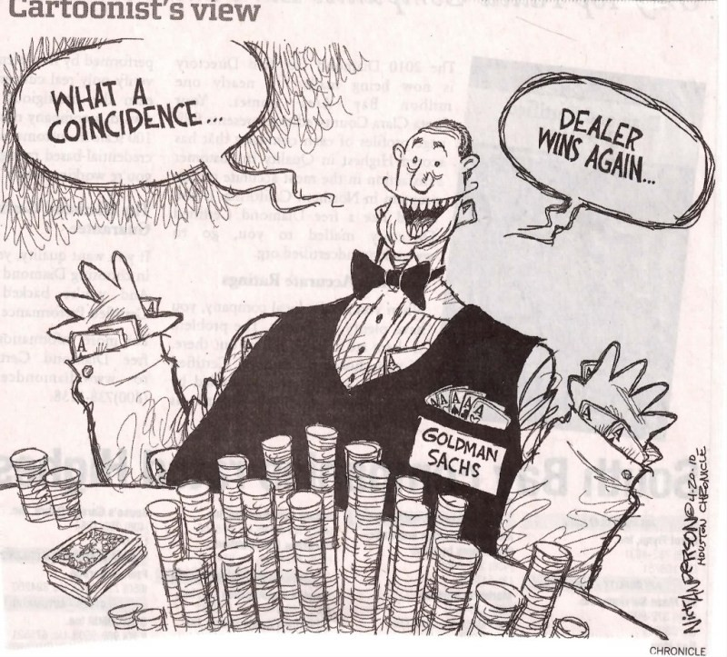
Contents:
Chapter one : Phycology
Lesson one : Risk to Reward
Lesson two: Risk management
Lesson three: Trading in the zone
Chapter two : Market structure
Lesson one: Retail support & resistance zones
Lesson two : Supply and Demand
Lesson three: Institutional zones
Lesson four: Importance of daily time frame
Chapter three : Liquidity
Lesson one: What is liquidity ?
Lesson two: Candlesticks scam
Lesson three:Wick rejections
Lesson four: Liquidity grabs
Lesson five: True market direction and order flow
Chapter four: FU Candles / institutional candles
Lesson one: What are fu candles and what makes them valid
Lesson two: Pure examples to demonstrate its power
Lesson three: How to enter as they form on all timeframes
Lesson four: Limit order strategy
Chapter five: Imbalances
Lesson one: Imbalances for market direction
Lesson two: Refined Imalances for sniper entries
Lesson three: Imbalances as they form and how to utilize them
Chapter six: XAU/USD (case study)

Chapter One : Phycology

Risk to Reward
Without doubt this is the most important concept in trading, one that is overlooked by retail traders who only focus on how many pips they have “caught” in reality they couldn't be more wrong. This concept MUST be grasped before we even think about progressing further onto market analysis.
In trading nothing is certain. NOTHING. No matter how good an analyst you are, the possibility always remains that you could still be wrong. But how do we avoid this trap of trading? (because that's what it is - a trap) simple. Risk to reward. How much are we risking ($ equivalent) for how much reward. And this is the concept that traders don't understand hence why they will always be losing. I feel the best way to make you as a reader understand will be a practical example.
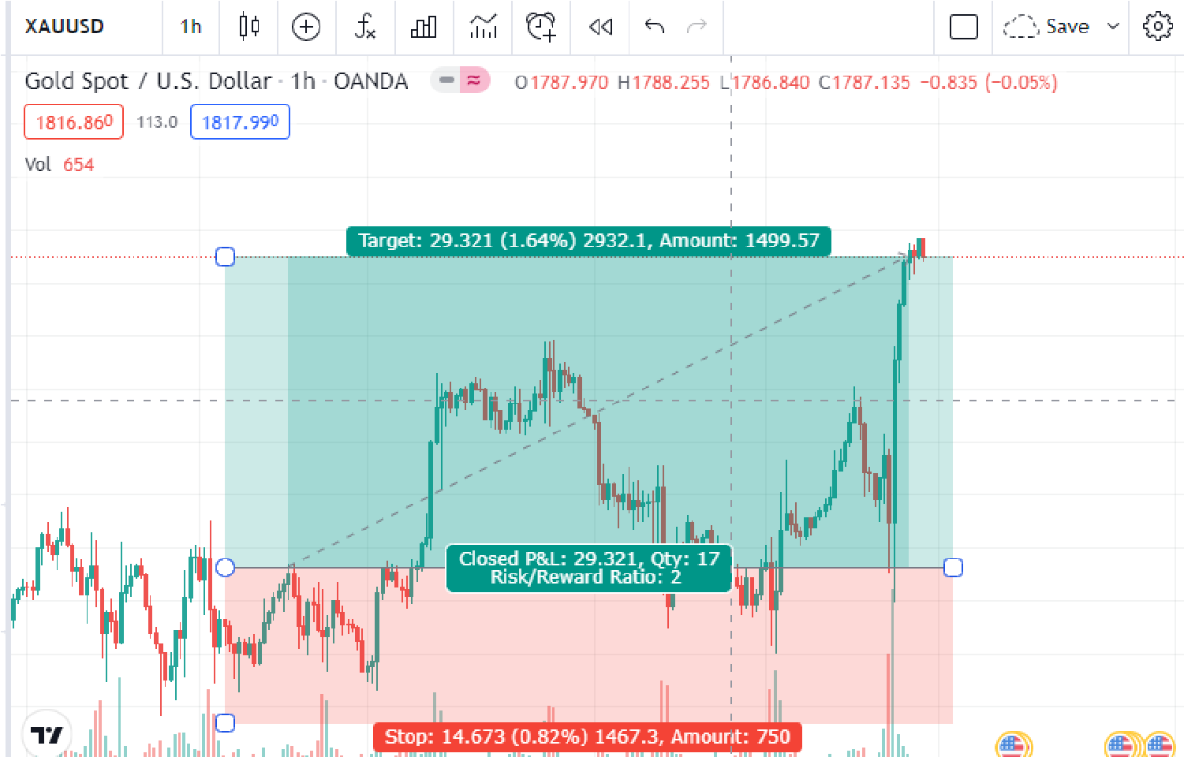
Retail trader:
Lets see the difference between retail risk to reward (although most of them don't even know or care for risk to reward) and institutional risk to reward. Here we have a classic example of terrible risk to reward. It is a 1:2 RR. which means if they had risked 1% they would have made a 2% return on that trade. Meaning their wins are only twice as big as their losses. Two losing trades negate a winning one. Paired with the fact most retail traders have a loosing win rate (below 50%) you can never make money trading this way. All the patterns they use to trade are publicly known and institutions hunt their stop loss thus further decreasing the win rate. Moving
on…
Institutional traders:
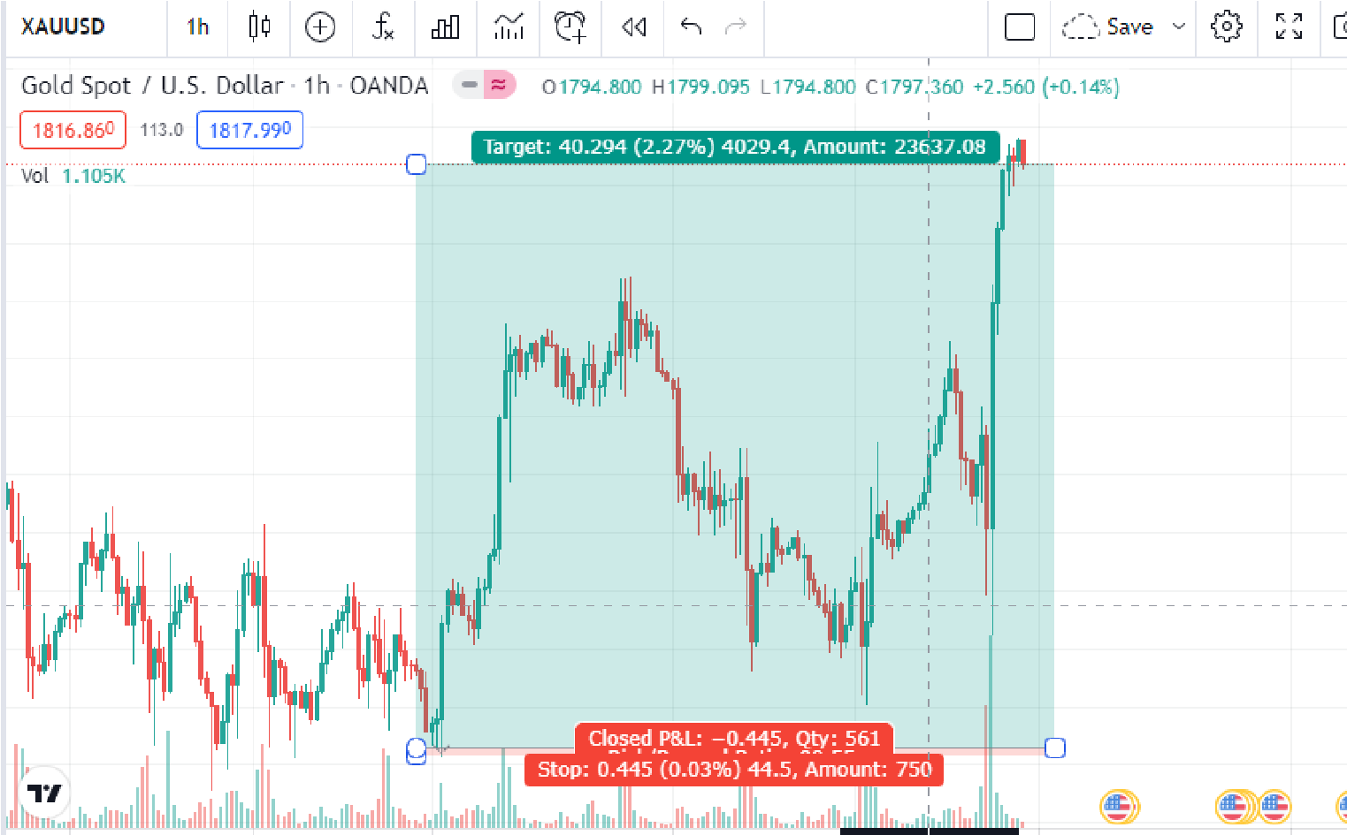
See the difference? A truly remarkable difference and honestly the biggest difference between being profitable or a losing trader. Here we have the exact same example. However as institutional traders we understand the importance of risk to reward and how it is EVERYTHING trading. This particular example is a 1:103 RR trade. Meaning if you had risked 1% you would make 103% back! See the possibilities now? Even if we lose 10 trades in a row one trade makes it all back! This can never be done with silly risk to reward ratios such as 1:2. I personally had the pleasure of taking this trade myself and only risked $800 for a $80000 return.
Please keep this concept in mind at all times! How do you improve as a trader? Work on increasing your risk to reward ratio NOT the amount of pips you catch! I can't stress how important this is if you truly want to make money and become profitable. This next picture really says it all!
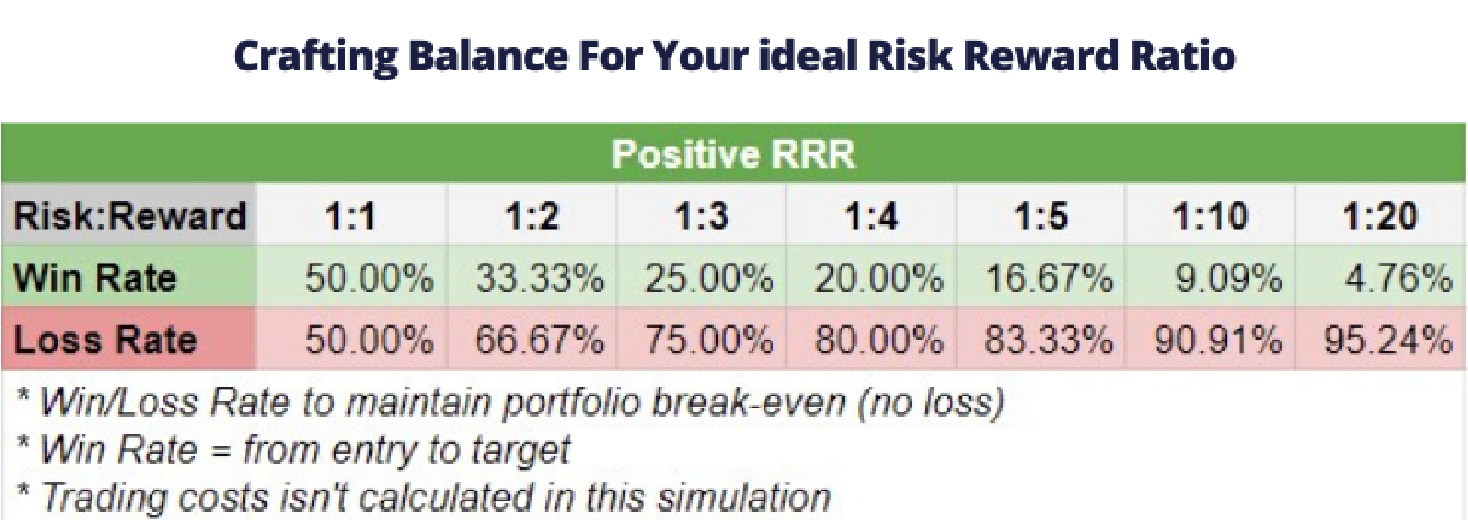

Risk Management
90% of all traders lose money. I'm sure you must have heard this statistic before. But why? Surely it's not that hard? Why do people keep trading if they know 9/10 of people will lose money? Trading is a game of the mind before anything else. This is why i have dedicated a full chapter to just psychology because believe me… it will be hardest to master all through your trading career. If your psychology isn't right, believe me.. No matter how good of an analyst you are you will always lose. As a matter of fact, I haven't come across a SINGLE trader who hasn't blown an account at least once. Now that's pretty crazy if you think about it. Everyone loses money when they start. What puts consistent winners apart from the rest? Simple - their phycology and ability to stick to a set of variables without letting their emotions affect them.
Two things will help you overcome this “hurdle” 1) high risk to reward trades (you risk very less for incredible rewards) and 2) risk management - how much should one risk per trade?
We will think in terms of % (in relation to your account balance) and it is vital you do not think in $ terms but rather %. I'm sure some of you have heard this 1% rule and for good reason too. It means you would have to have 100 losing trades in a row to lose your capital and blow your account (highly unlikely impossible in fact). However I disagree with this concept as we trade with massive risk to reward so one win covers our losses by a big margin. Therefore I recommend 3 % for larger account sizes and up to 5% for those of you growing a small account (1% is simply impractical if you have a $100 account risking only $1 you wont make money for a long time)
However, I must stress! Stick to a fixed % risk per trade and NEVER change it. You MUST keep the variables on per trade as similar as possible in order to see a consistent result. Assuming you have a 1:10 RR minimum per trade. That means even if you lose 10 trades one will cover that. But if the % risk per trade varies this formula does not work. So stick to a fixed % risk
Why still do people blow accounts? They simply do not account for risk which is paramount if you ever wish to be a consistently profitable trader. Humans are greedy and if you come with that mindset in the markets.. Say goodbye to your capital. ALWAYS account for risk. It should be the first thing you do before placing a trade.
Remember the main thing is to preserve your capital before making money. Remember this as a rule whilst you trade and it will help you from making silly mistakes and getting emotionally involved.
Trading in the zone *A must read*
One of the turning points for my trading career was reading this book. It really is an eye opener. If you are struggling with psychology I recommend you stop trading immediately and read this book. It goes deep into market psychology and really gives you a whole new perspective on trading.
I hope you as a reader don't skip this step because you will regret it. Before moving onto the next chapter read it first. We must build the framework for a solid trading journey.
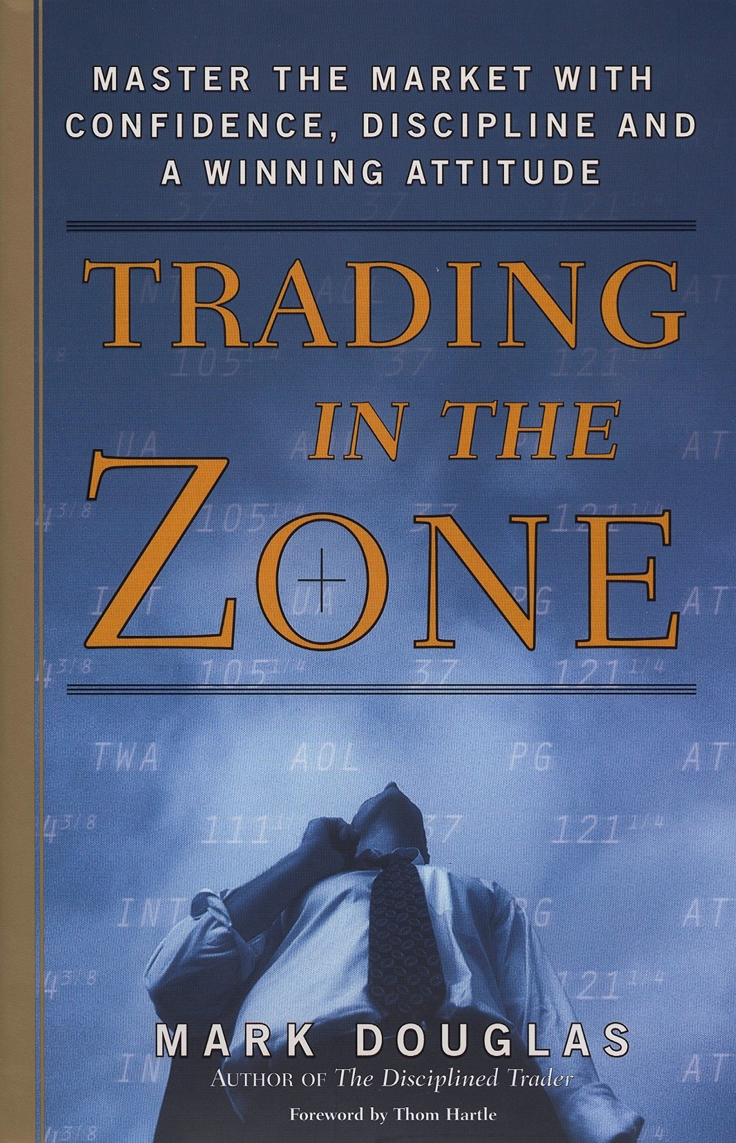

Chapter two: Market Structure

Retail support & resistance zones
No matter how amazing of a trader you think you are, market structure is always first. Price can be manipulated but in the end market structure is first. Why do I teach the standard retail zones? Because in essence it is right… price can not travel infinitely in one direction.
We will only use the daily time frame (its importance will be talked about in another lesson) and the 4hr to refine it. Lets go through one on GBP/USD so you understand the concept.
Daily timeframe
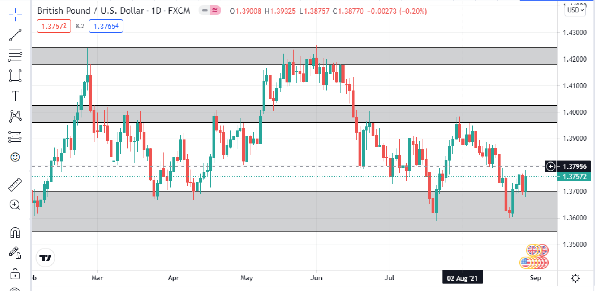
All the places price reacted from we shall mark out. Don't worry about being 100% accurate these purpose of us doing this is for a general understanding of the market. Then we go to the 4hr time frame and further refine our zone. After I was done this is what I got:
After 4hr refinement
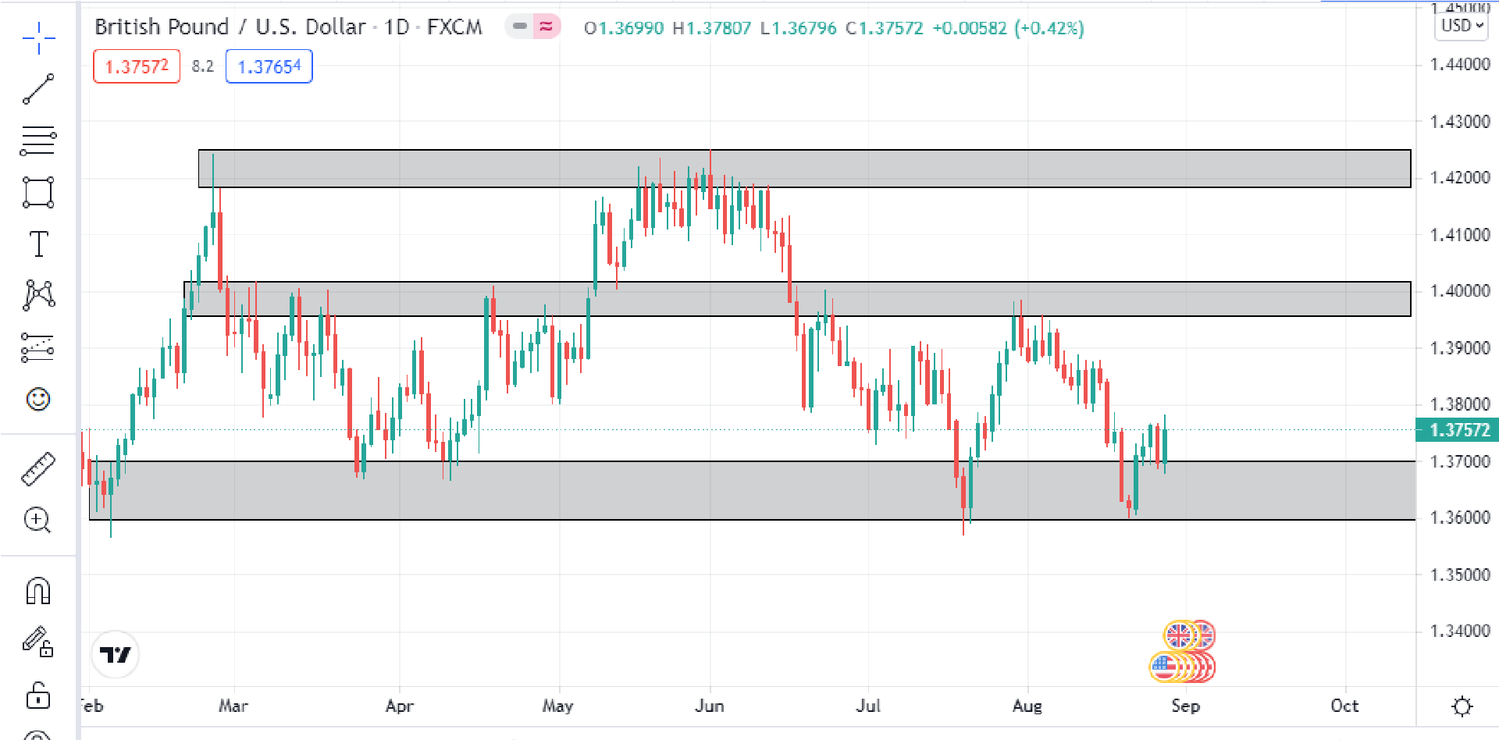
Now we have a much better look and understanding of the market. Reach one of these “zones” represents an important area which price will likely react to. However it is not very precise hence why we only use these as a possible reaction area but also to determine market direction.
Price MUST break and retest every zone before continuing in its desired direction. If price suddenly smashes two zones we KNOW that price will have to come back for the retest in the long run so we can determine our bais (opinion on buy/sell) using it. Maybe you will be able to spot that instance in the above example.
Again this is not used as an entry point nor do we really care for its relevance apart from the fact market structure is always first and must not be forgotten regardless of how experienced a trader you are.

Supply and demand
Now we are getting into it. You have understood the basic principles of market structure which is very important but also common knowledge and quite limited as these zones are very big without any real accuracy.
Trading is always about understanding the markets, not just finding patterns and placing trades. NO! It's far more deep than that. We must understand the principles behind each move and supply and demand helps us with that. What is the market we see when we open up trading view ? Its nothing more than a means of showing us who is buying or selling. If more people buy price goes up. If more people sell- price goes down. It's as simple as that. However as the market is full with an infinite amount of traders they often leave patterns which may be capitalized hence how technical analysis became a thing. The point I want you to understand is that we as people move the markets, not the charts. Maybe some of you knew this but it's an important concept to keep in your mind
Why did I even include supply and demand? I debated with myself to include this or not as it is a hard subject to explain and goes in a lot of depth (after all it is the fundamental of the market)
Simply put. Price will never move in one direction forever. It will ALWAYS either move between supply and demand areas. Sort of like ping pong if the example helps you understand better. In order to sell you must have a demand and in order to buy you must have supply! Hopefully now you are grasping this concept and how important it is because this has to occur possibly the only thing certain about the markets.
See it shown in this example. It is not support /resistance but rather we identify the last area where sellers/buyers were present. If price breaks it then we know it will move to a further area of supply/demand
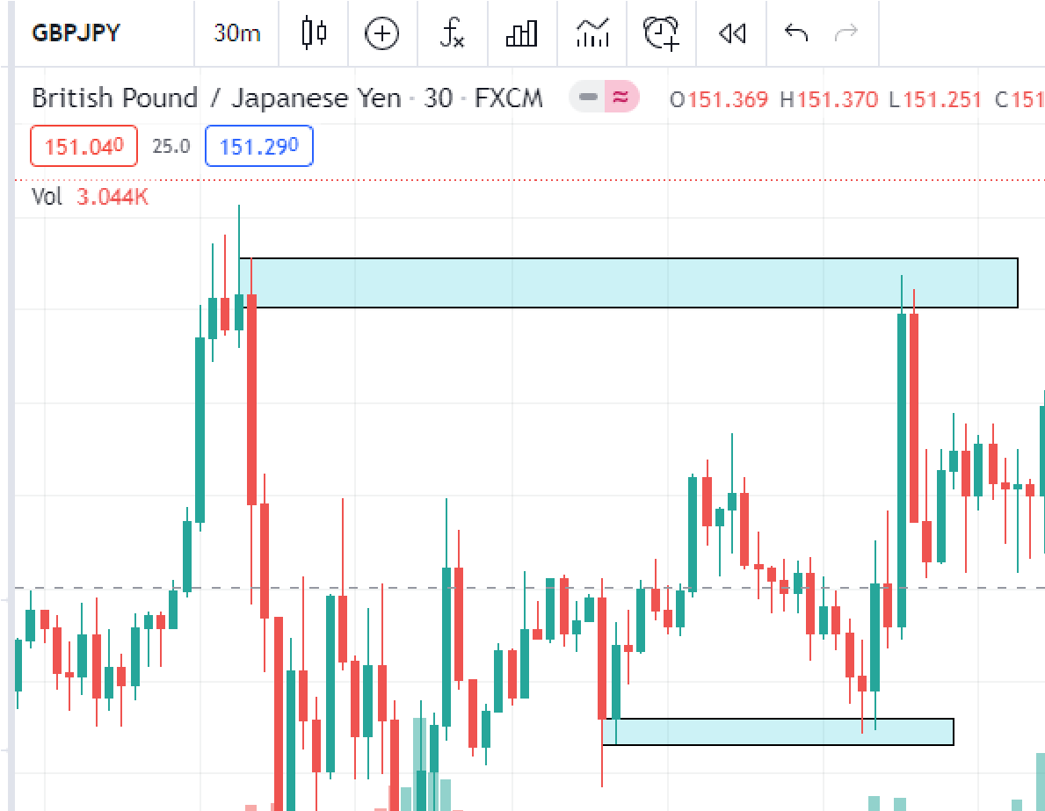
Institutional zones
10
Here is where things really start to get interesting and the first step to finding sniper high RR trades. It is truly mind blowing how just making this one tweak to your charts changes everything.
Before we get into it we must first understand the concept of an “order block” It is an odd bearish candle before/or during a big move up or a weird bullish candle before/or during a big move down. This is the first concept we will learn that discusses market manipulation.
When banks/institutions want to move price up they simply can not just do so. Due to the principle we discussed in the last subject “in order to buy you must have someone to sell and in order to sell you must have someone to buy” Its crazy how this is exploited. What they do is before wanting to move the price up they will open a large amount of sell orders (to push price down) for two reasons.
- So that they introduce sellers to the market (people seeing a bearish candle close will sell) thus further increasing the supply - as they intend to buy.
- So that they may get in at a “discounted” price. I.e move price down to a lower point than it already is just so they can buy at better price
It may seem a little confusing to you at first but its important to understand the “science” behind it. I've attached a link that will really help you understand the order block concept. We do NOT use these for entries such as “smart money traders” do but rather we only use it to find accurate zones (so ignore any parts they mention about entering using an order block) https://www.priceactionninja.com/trading-ict-order-blocks/
Now that you have understood what an order block is let me demonstrate a few examples that show its effectiveness and how to correctly draw our zones.
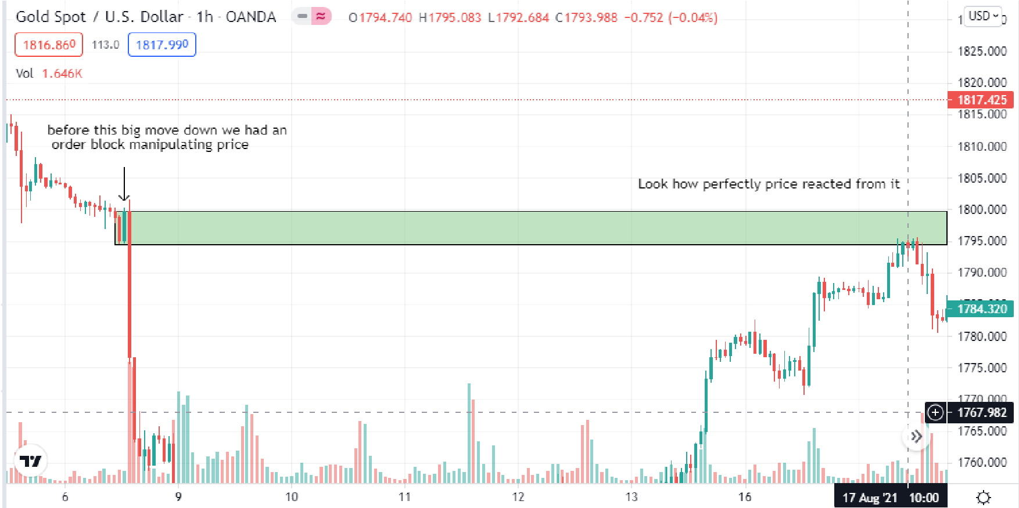
11
We had a picture perfect order block so obvious and you should have marked this out as you saw it form. It is now our permanent institutional zone. Order Blocks are basically true support and resistance. Lets drag this zone on further to see what reactions we get.
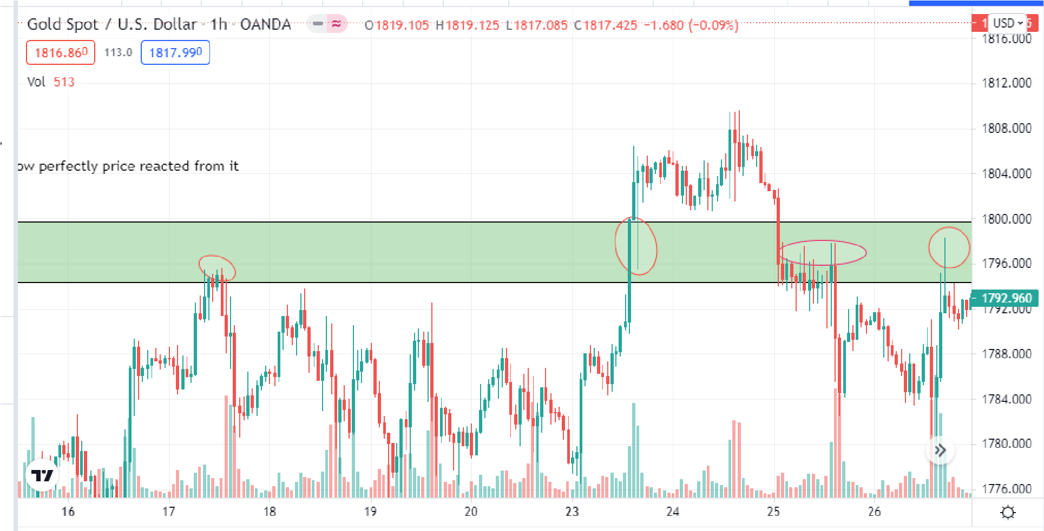
You will never find this kind of accuracy with any kind of retail zones and this truly will be a gamechanger to your trading journey. And this is just one zone on one timeframe! You can see this repeat constantly on all timeframes although I recommend to use 30 min - daily time frames.
Only include the body of the order block not the wicks for maximum accuracy although you may include the wicks if you decide.
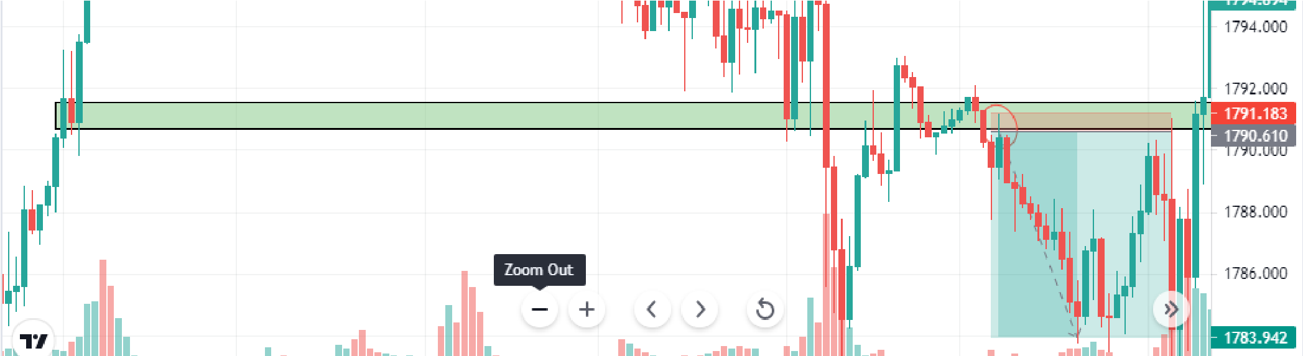
Another example on the 30 min time frame. You could find a really beautiful entry where I circled and we saw a perfect reaction. But of course this is just one confirmation and we must have others of course. But this MUST be one of the confirmations to take a trade.

Importance of the daily timeframe
This is something a lot of institutional traders forget. More so than retail traders. Part of finding insane risk to reward trades means trading on a lower time frame such as 1m or 5m. However… it is useless if it doesn't make sense on a higher time frame especially daily. Once you understand the daily timeframe you understand market direction and that is the core of any trade you place.
Do not neglect this and always ask yourself whenever placing a trade… is it aligned with the daily timeframe? In other words.. Will it make sense to place this trade?
The higher the time frame the more strength it has. For example 1hr contains 60 1 min candles. Daily contains 24 one hour candles. I'm sure you get the maths and just how important it is to always have a higher timeframe confirmation. Personally I neglected this concept during the start of my trading career and I was always fighting the overall trend of the markets in hopes to find “sniper trades”. Now i still find sniper high RR trades but its always alongside the trend of the market.
So do not neglect this. You will not be able to find entries on this timeframe (if you did I would assume you're a naive retail trader who has massive SL) but its importance in market structure is vital and you must focus on it. Keep this in mind as we cover new concepts such as liquidity.
Chapter 3: Liquidity What is Liquidity?
Possibly my favorite subject to teach trading. Because I know that for you ordinary retail traders this will really open your eyes to just how rigged trading is. Rigged is a harsh word but it's the truth. Be prepared to forget all that you have learnt about trading because from here we will cover the ONLY concepts you need to know. NO MORE. This is as simple as it gets.
Liquidity is wherever we have a lot of traders get into the market and their stop losses are visible. Not visible in the physical sense but it is apparent where they would have placed their stop loss. Example: we have a doji form. We know retailers see this as a sign of “reversal” so they will buy/sell with their stop loss above/below the doji (depending if it's buy/sell.) Everyone can see with one look wherever their stop losses are and so can the banks who manipulate price as they wish.
Remember what I said before? In order to buy you must have someone to sell and in order to sell you must have someone to buy. This is where liquidity comes in. Banks will purposely “generate” liquidity - tricking retailers into trading the opposite way they intend just so that they may have people trading in the other direction so they may steal their money.
Because that's what it is. If you make a profit, someone else is losing it is as simple as that. Now do you understand? Just how manipulated the markets are? It's actually quite evil if you think about it but we can't expect more from these big institutions who only care about their own pockets. IT'S TIME TO BEAT THEM AT THEIR OWN GAME! .
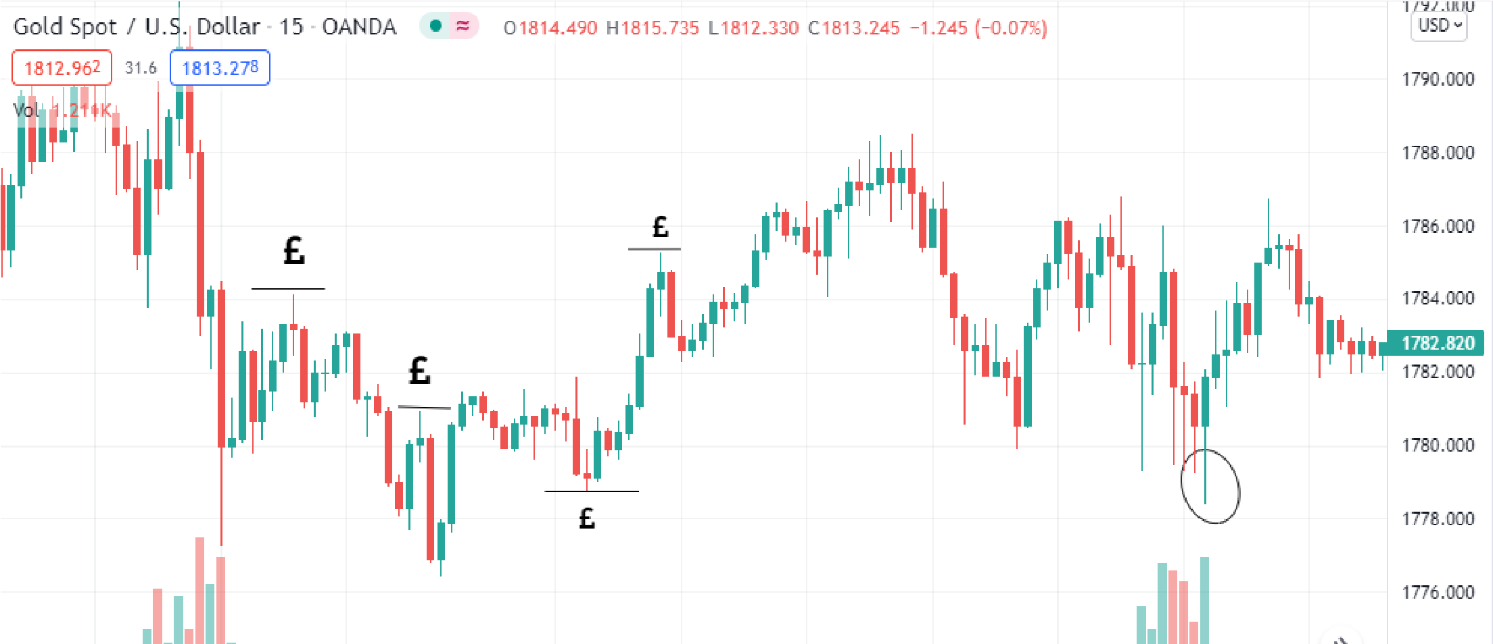
Lets look at an example on the 15m timeframe on gold each £ sign would represent where liquidity is i.e where the stop losses are. Lets keep it simple and focus on doji traders. This is truly where you understand the nature of just how manipulated the markets are. Each time retailers got in the banks gave them a small reaction but eventually always took them out. No chance for big RR trades when you're constantly getting hunted.
Each time liquidity was generated it was hunted. You see a clear example that I highlighted at the end. Price wicked below the doji and then flew in the other direction. A “liquidity grab” which we will cover in a few lessons.
The reason for this screenshot is to highlight to you how retail concepts will never work - they are sl hunted meaning you can never trade fairly. You may at times earn a little but overall remain on the losing side.

Candlestick Scam
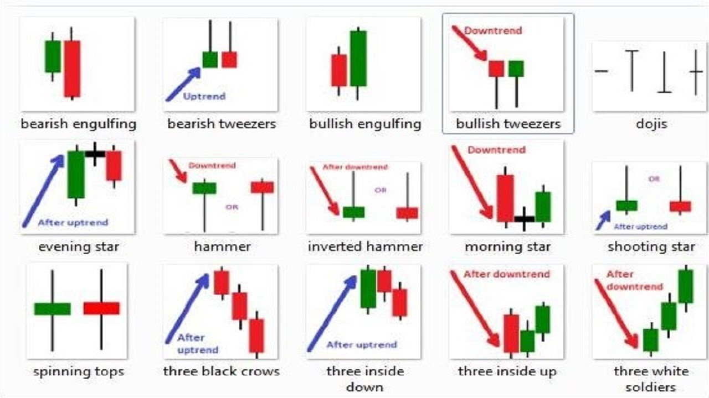
You need to forget all these patterns. We do not see these as a confirmation to take a trade and they are ultimately just generating liquidity before the true move. Remember… We do not trade on the side of retailers who will be made to lose. We see these as symbols generating liquidity and we can understand the true markets using it to find the true market direction.
Some patterns we will focus on:
- Doji- to retailers it is a sign of reversal. For us it is a means of generating liquidity.
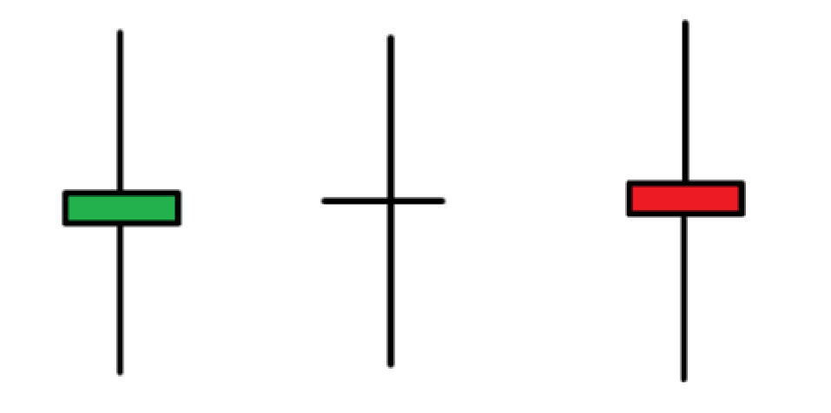
- Double tops/ bottoms
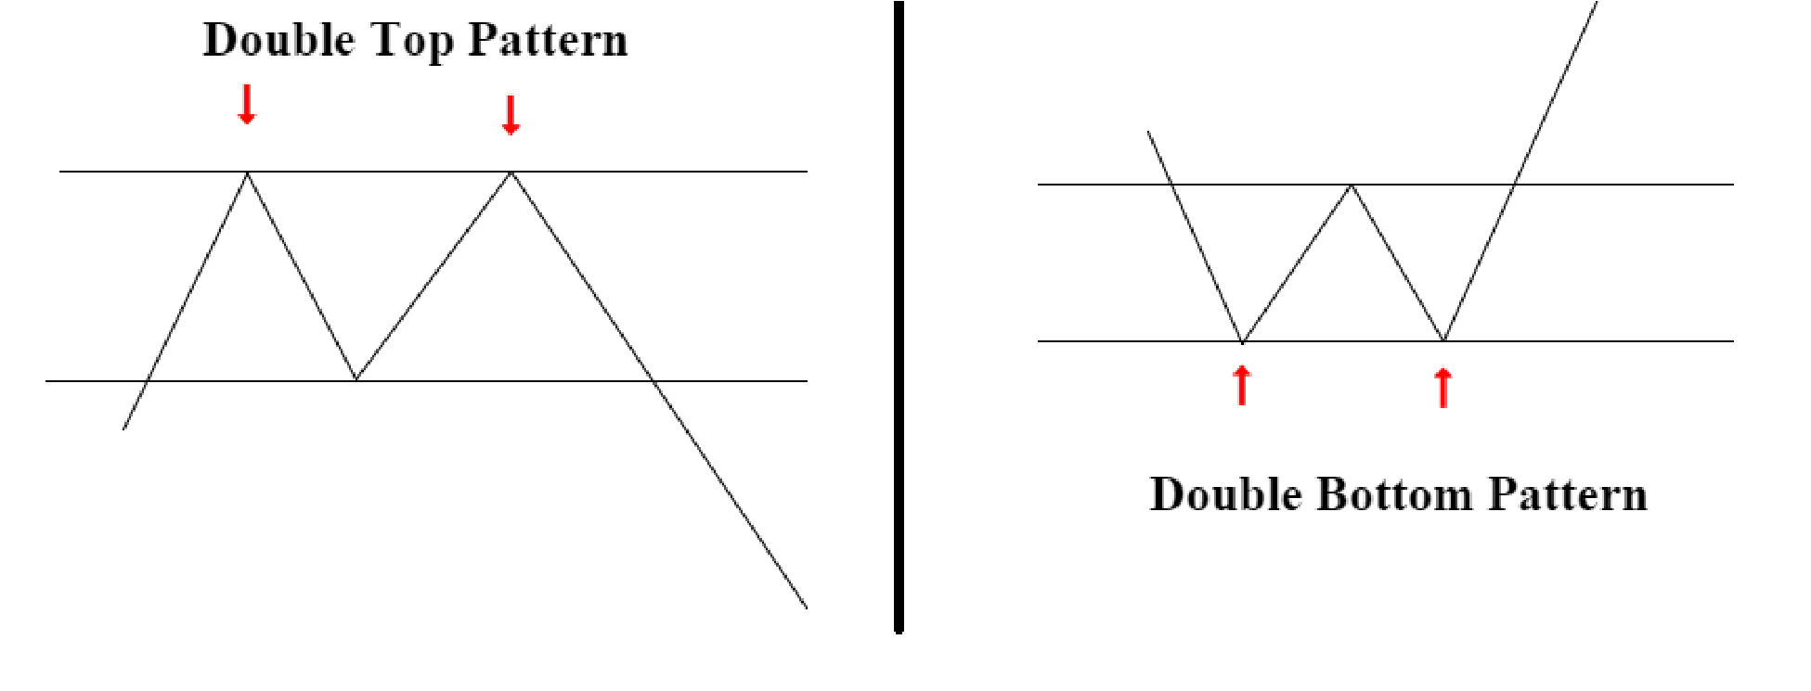
Another sign of liquidity we know retailers are selling using this and where their stop losses are.
Just remember these two as they are the most common and occur very frequently.
The only real patterns that we use are two. One are Fu setups which will be covered later in depth and the other:
Fake doji:
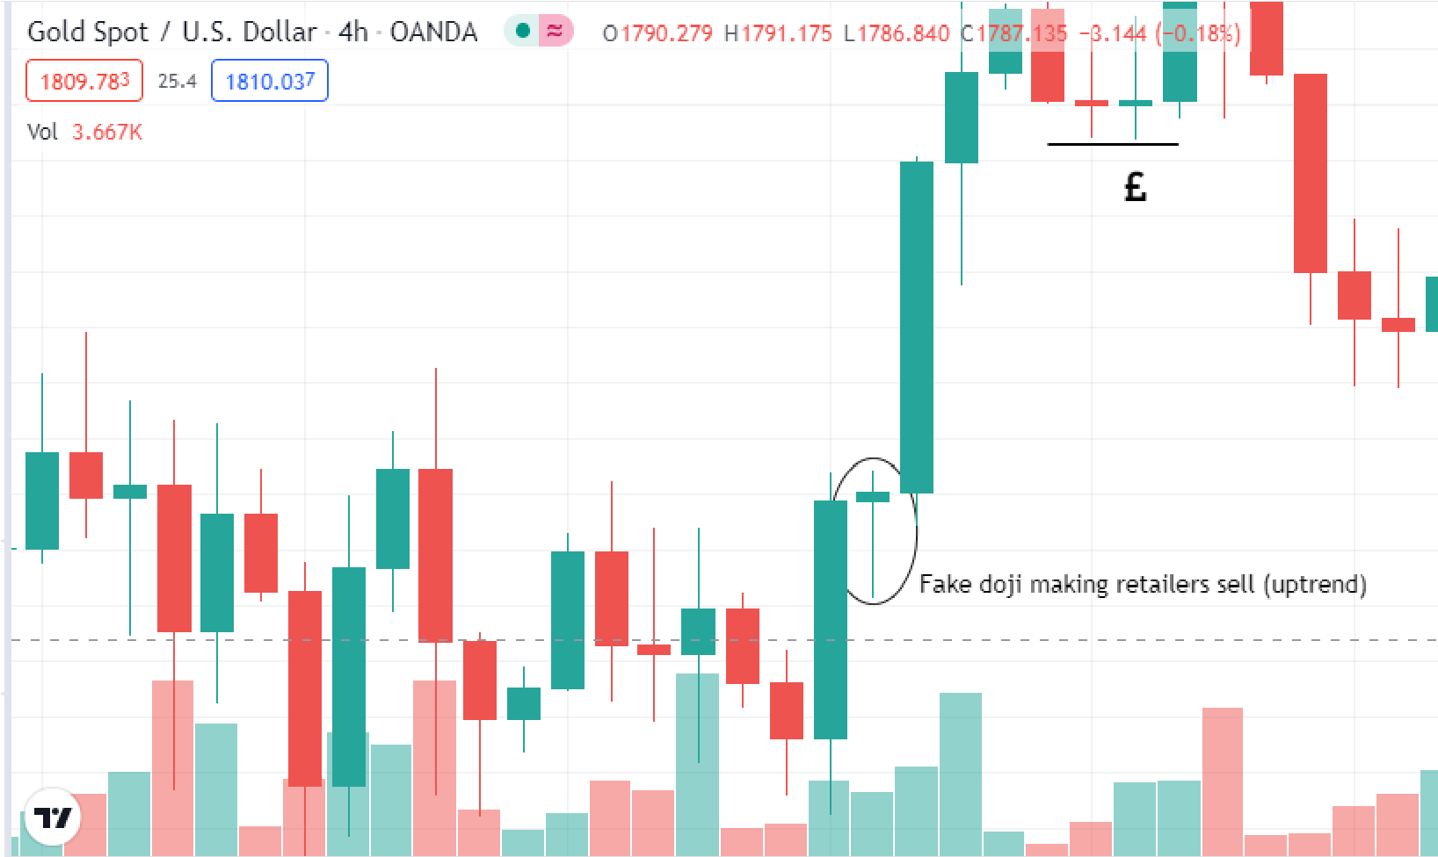
Uptrend
Downtrend:
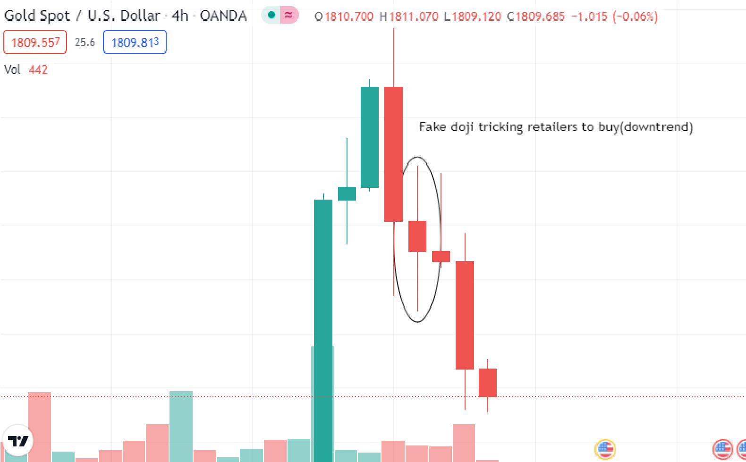
It occurs a lot more frequently than a “real” doji and is a sign that we are trading in the right direction. Remember what I said? We do not trade with retailers. It is the only pattern you should look for. The science? The doji made liquidity inducing people to trade in the wrong direction. Then took all their liquidity (money) to move price further down.
This and Fu setups are the only times you will follow a “pattern” a pattern yes… but based on the psychology of the markets that banks exploit.

Wick rejections
We will keep this simple. Big wick rejections = liquidity (retailers looking to get in due to a big wick) one of two things will always occur.
- Market makers will decide that too much liquidity has been generated therefore they will hunt the bottom of the wick ( too much liquidity)
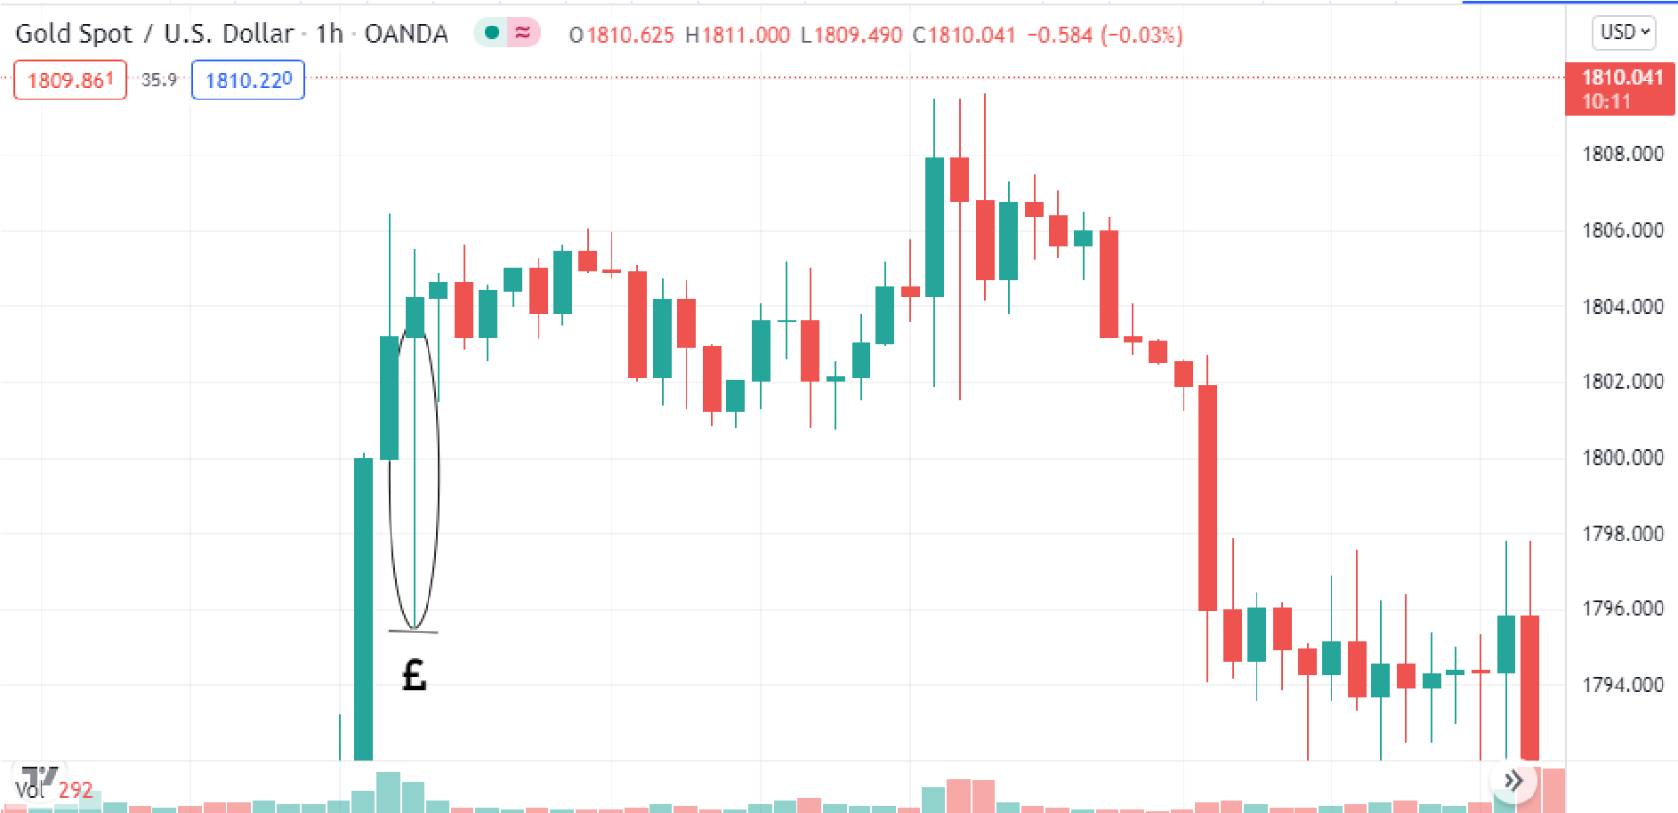
- Price will come to “fill” in the wick. They may not fully hunt the wick (in the instance of a true liquidity grab) but they will ensure that the hasty buyers seeing the wick get taken out before moving price in its original direction
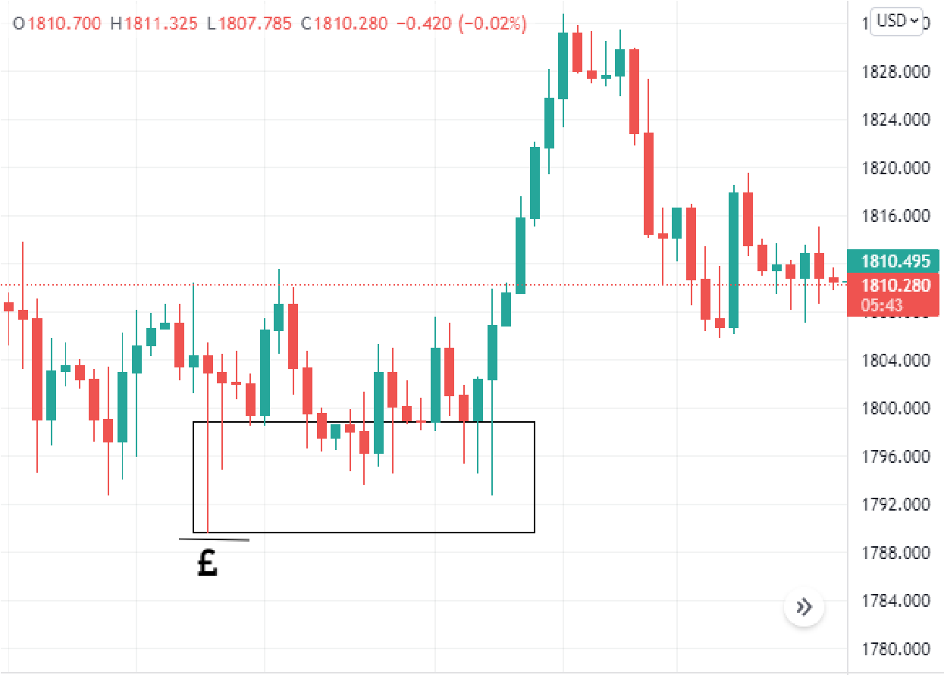
Liquidity Grabs
The name says it all. A liquidity grab can be a good way to find sniper entries and can also be used as a confirmation for market direction even if you don't get in using it. Remember this rule as you trade “the market is always attracted to liquidity” you will see liquidity grabs occur on all timeframes and on a regular basis. This is best understood with an example:
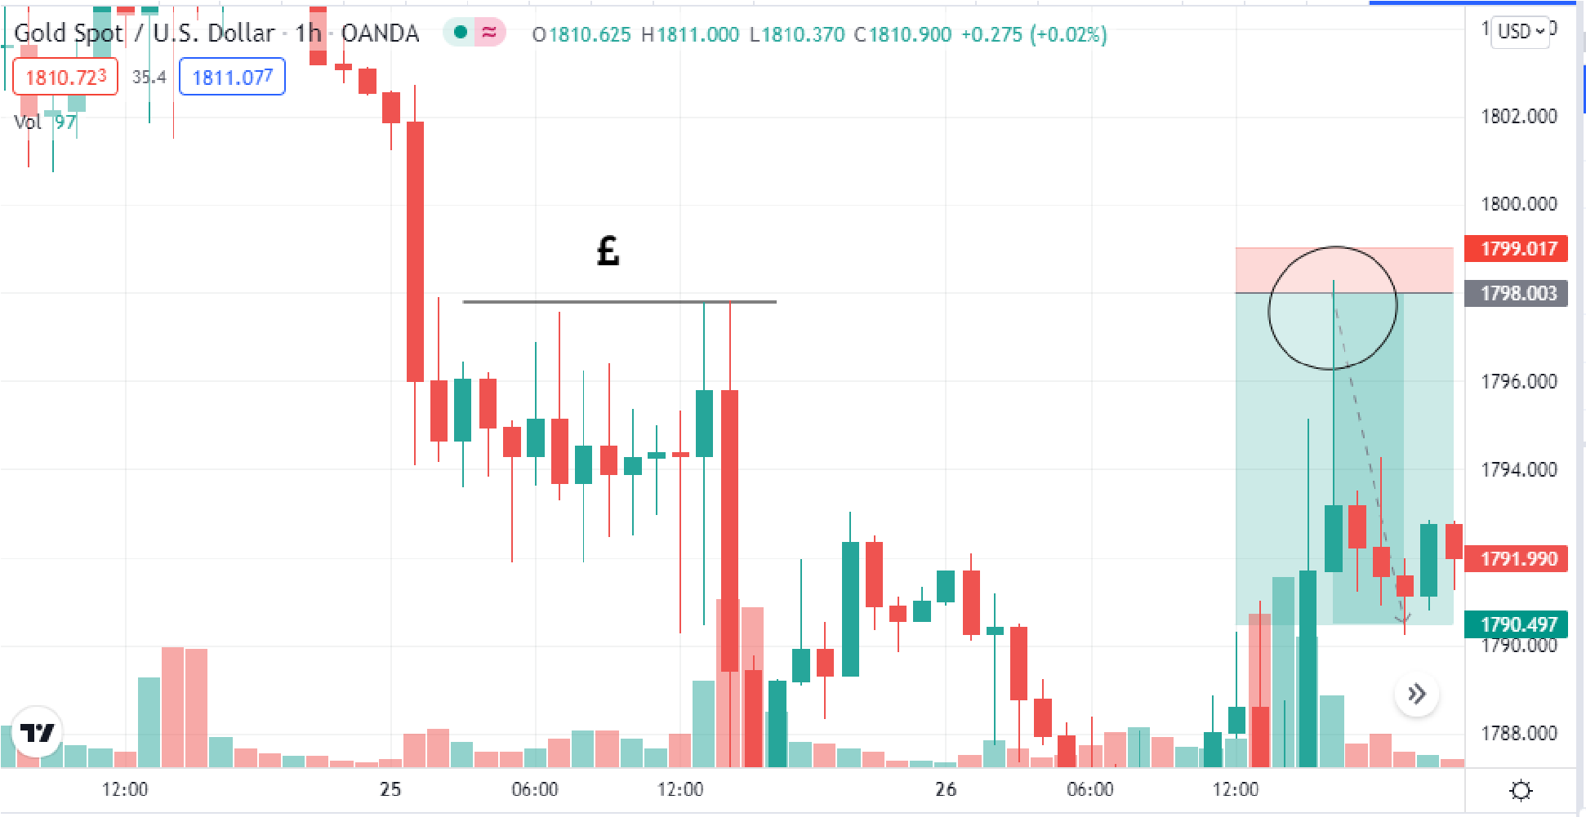
The £ sign shows where liquidity is, in this case we have a double top where we know generated liquidity. We will be expecting this liquidity grab and place our sell limit slightly above where we know the stop losses to be. Look at the perfect reaction price gave. You can find beautiful sniper trades this way.
This is your first practical “strategy” - trading liquidity grabs. It is fairly simple to understand :
- Find liquidity
- Place your buy/sell limit slightly above
- Keep a small stop loss- it either works or doesn't.
Another example:
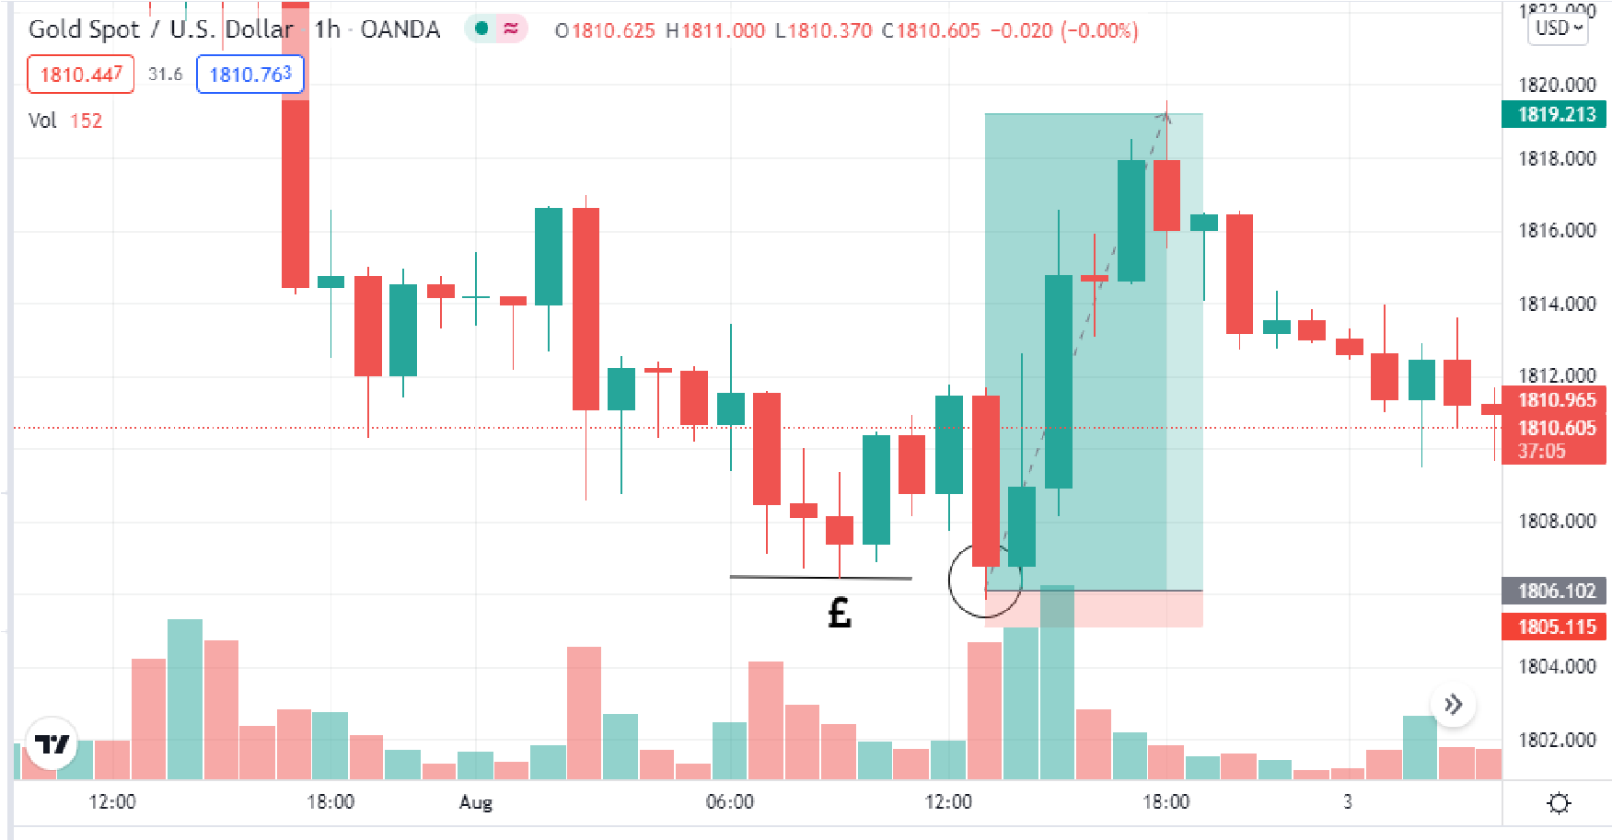
In this instance it is a doji which has generated liquidity. We know that slightly below it is where all the stop losses are, so we will place our buy limit with a small stop loss.
It is my job to inform you of the successful ways to trade but I must also present to you its disadvantages. The problem with liquidity grabs is you may get confused with market direction always expecting a Liquidity grab and for price to go in the other direction. This isn't the case however everytime and it is here where having correct market direction comes into play. Only take the trade if it has a higher timeframe confirmation.

True market direction and order flow
Now that you have understood liquidity, understanding market direction will be easy. If you see liquidity … target it. If you see liquidity taken .. you know your trading in the direction. Its really that simple. Our job is to trade in line with whatever path has lower liquidity. As with anything in life it's one thing for me to explain it to you but you must open your mind and train yourself to identify and follow liquidity.
Remember what I said about the importance of the daily time frame? Well if you can identify liquidity correctly on 1D timeframe you will have no problem wondering which way to trade on an intraday basis. Example on gold daily:
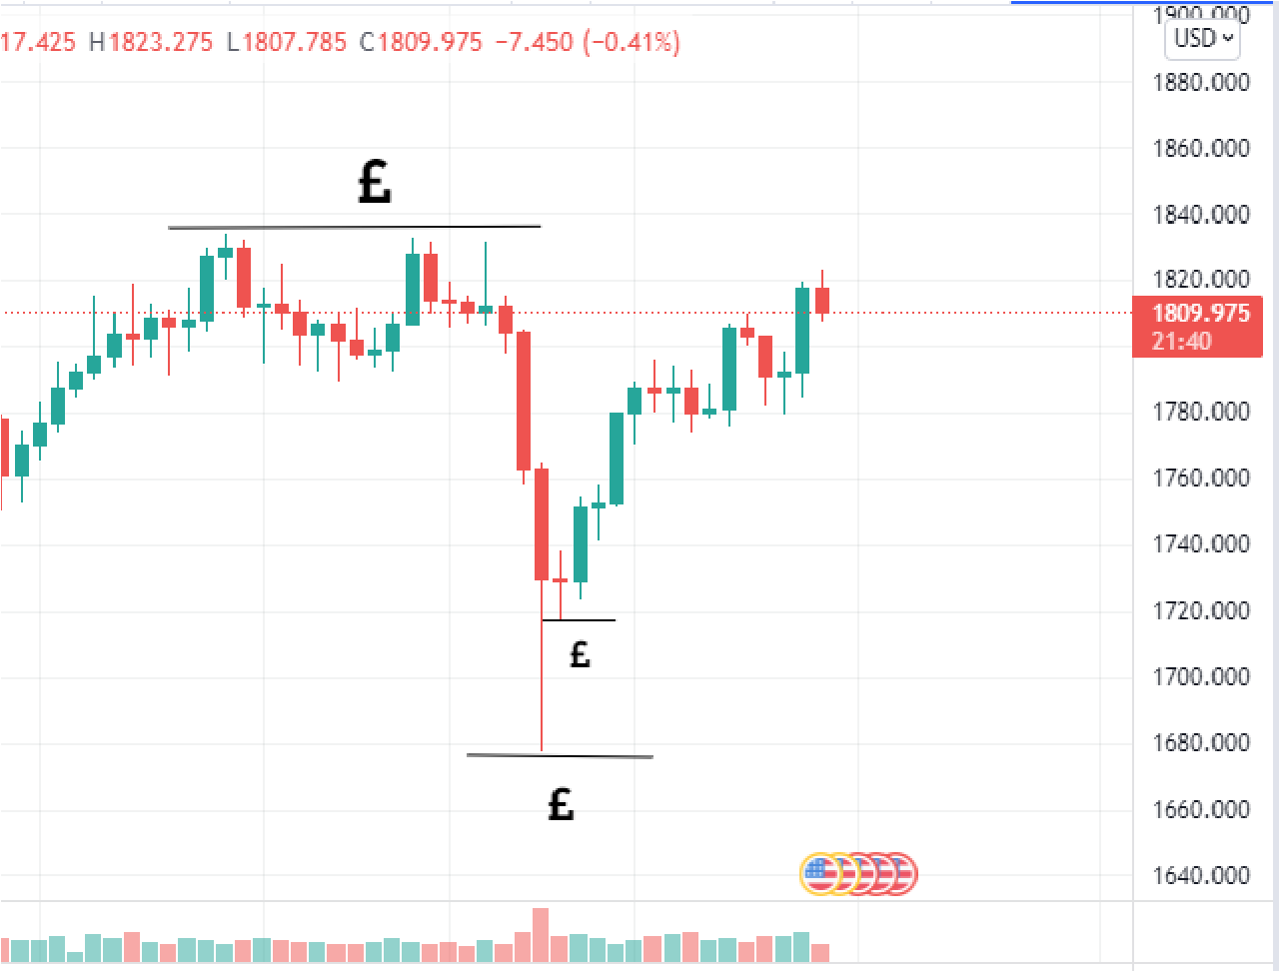
Price will either hunt buyside or sellside liquidity first (top or bottom side liquidity). To the top side we have a triple top and a few dojis = liquidity. And to the bottom side we have a daily doji and a big wick , both generating liquidity.
By this basic liquidity analysis we can see that price is intending to go further down ( leaving a big trail of liquidity) but first they will take all liquidity from the top side. It's as simple as that. After we see the liquidity at the top (1835 level) we will start looking for sells to target liquidity below. Using liquidity we have now determined true market direction.

Chapter four: FU Candles / institutional candle

What are fu candles and what makes them valid
Fu candles are truly amazing. They occur on all timeframes over all pairs and they mean one thing. It is a sign as to what direction banks are trading. A “physical” sign just as candlestick patterns are only these really work. It's really unbelievable how many times this occurs in the markets yet so few know or speak about it. True information about the markets will never be public otherwise how could the banks make their money?
Fu candles must have two confirmations in order to be valid.
- It takes liquidity
- It must break the high/low of the previous candle (lose below
A true FU candle:
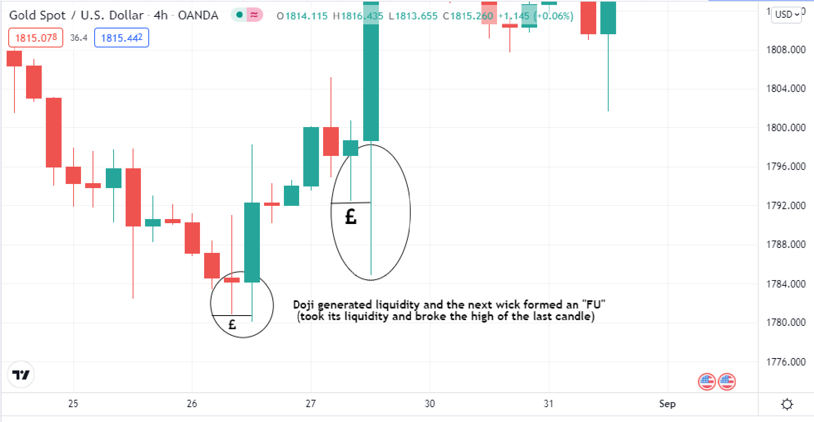
We most commonly see this occur with a doji or double top/bottom. It doesn't matter really as long as something generated liquidity and then was taken. The purpose of this lesson is nothing more than to train your eyes to see this pattern in the markets

Pure examples to demonstrate its power
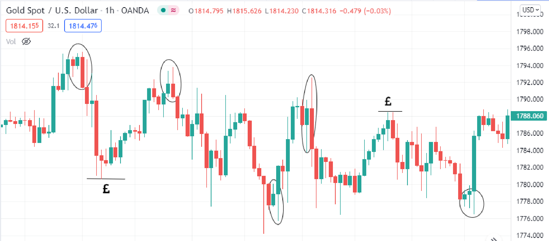
In this one example we see 5 fu formations. Each one for more than 100 pips move each time. Price also kept coming back to the last area of supply and kept reacting from the previous FU (a strategy we shall talk about in a later lesson.)
When each of these moves form, you understand which way banks are trading. Eg: see a fu form to the downside then we know banks are looking to sell. If it forms to the upside then we know banks are looking to buy. Remember : we look to get in when liquidity has been taken and when we have liquidity to target. And Fu setups are a prime example of a move with no liquidity generated.
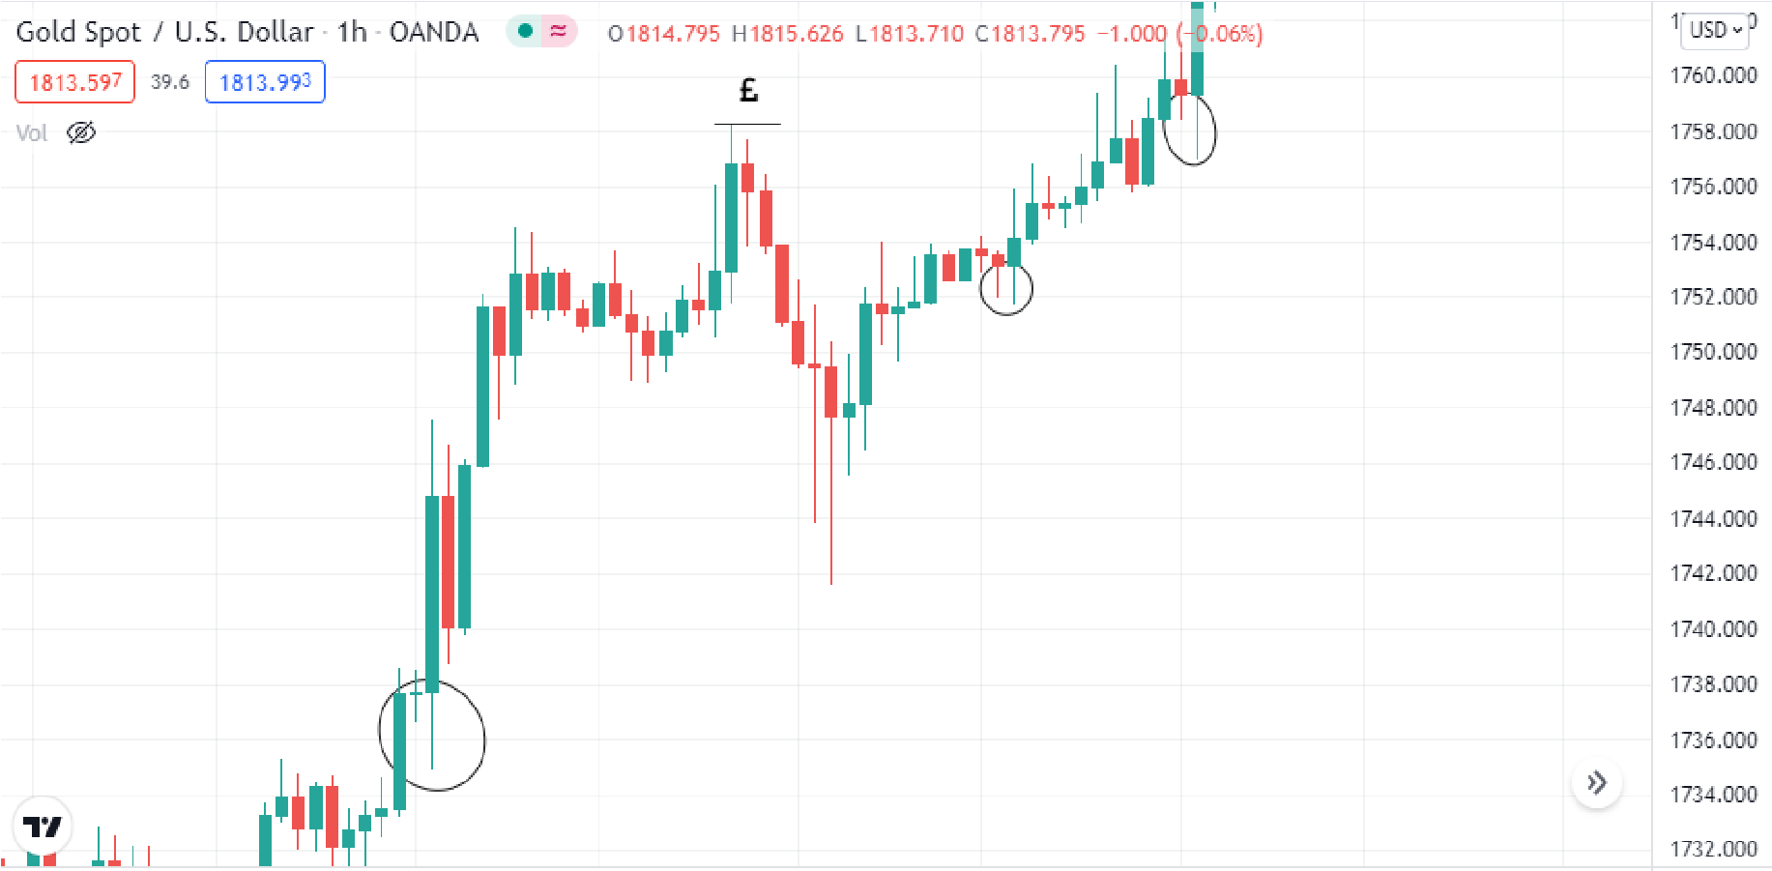
Another example. Here we see banks really wanting to move price up. 3 fu setups have been shown. A doji formed (generating liquidity) then the candle after briefly wicked below it taking all the sl of retail doji traders then flew in the other direction. Using this we find amazing entries (if found as forming or re entries using limits)
Remember we find these on all timeframes. For example if someone wanted to trade on the 1m or 5m this concept still applies. Allow me to demonstrate:
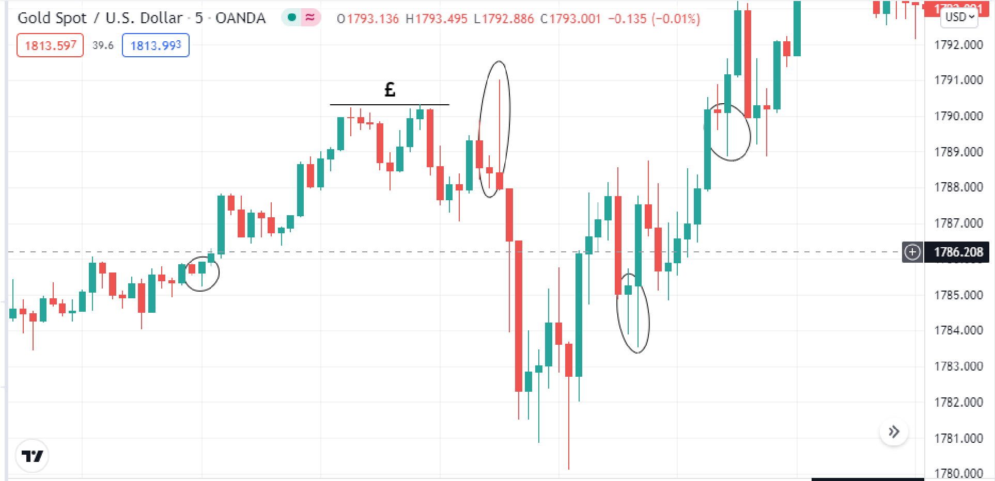
The 5 min time frame on gold. Each circle shows us an fu opportunity. The possibilities are really quite endless considering it appears on ALL timeframes. So if you don't see it on one you will on another. That's the beauty of it. Combined with all the other concepts we use this really helps us to put it into practical use and find entries using it.
Enter after the fu candle closes (whatever timeframe you see it on) and put you sl above the wick on the fu. That's one way to enter using it. Although personally I always want to keep my sl small so only use this with smaller time frames. Otherwise I use it for market direction or only limit orders as will be explained later.

How to enter as they form on all timeframes
Now you know what an FU scenario is / what it looks like. How to gain absolutely maximum risk to reward using it. Well its simple, we enter as it forms.
As you are a beginner i would only recommend using this on forex pairs at least until you are comfortable enough to trade more volatile pairs like gold.
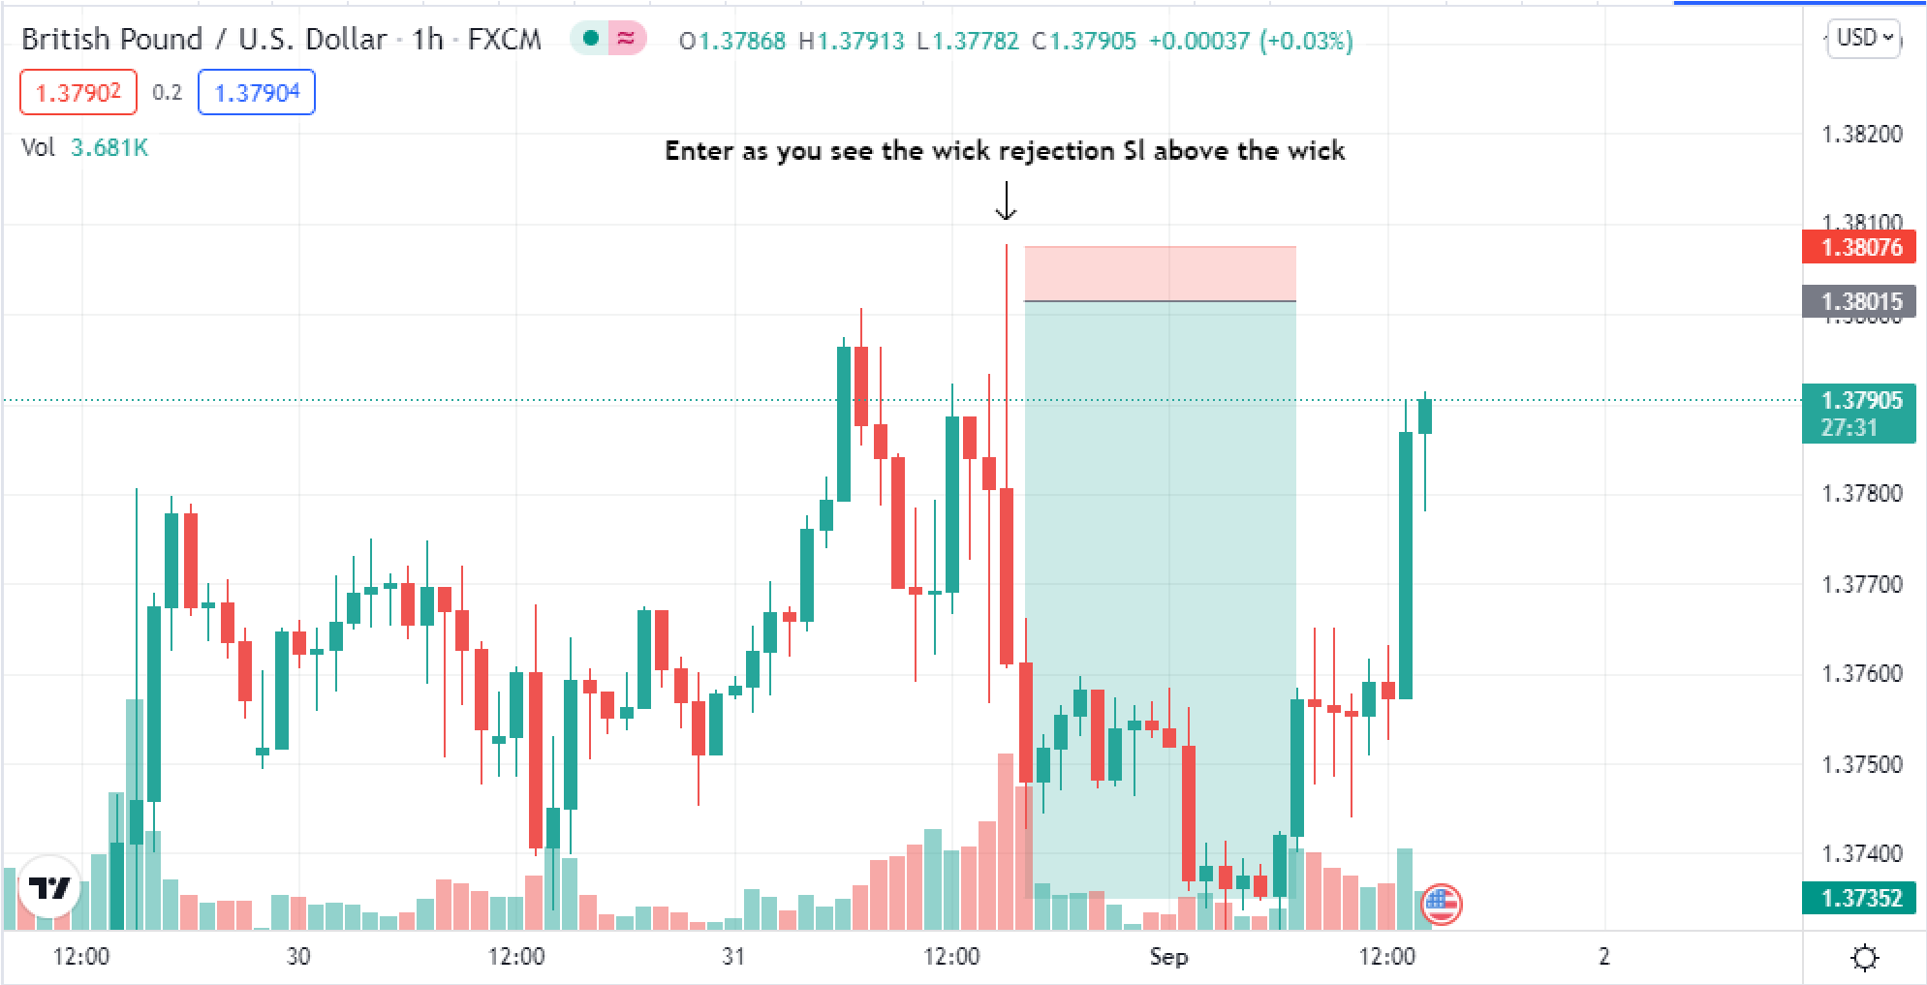
Now remember we are trading with the banks not the retailers. Retailers see an doji and sell we only take trades after manipulation has occurred and liquidity has been taken. This is why liquidity is before FU setups in this book. Liquidity is a fundamental aspect of the market and must be mastered before actually applying it. When you understand liquidity you will understand what Fu setups make sense (as they form)
I say to only do this with forex pairs for a start because it moves slower and you will be able to get used to seeing and entering as FU setups form. When you master this and move onto gold..
Lets just say you will be very surprised at its effectiveness.
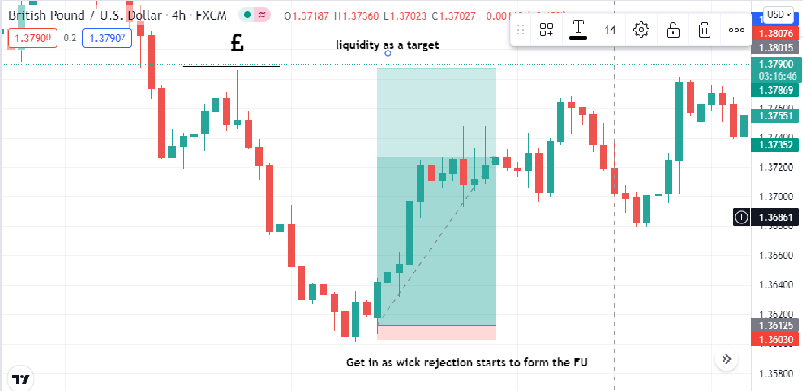
Let's look at another example on the 4hr time frame this time. Exactly the same concept we see an fu forming and we get in. But always wait for a wick rejection first so you know where to place your stop loss. I'm sure if you open up your charts you will find countless examples of FU setups ity will honestly surprise you why no one is talking about them. The banks don't want you to know. Even when they manipulate price they leave traces and we can maximise on that.
Remember this is lesson 4. And as such all the other lessons come before this. It can be very easy just wanting to hop in every time to see an FU forming but no! You must have correct psychology, it makes sense with market structure and liquidity is taken /targeted. Once that is in place only then you may move forward looking for these kinds of setups.

Limit order strategy
The science behind the retest of FU candles is amazing. It is a means for the banks to generate the most perfect low liquidity moves as they move price in their intended direction. First an Fu is formed taking all the previous liquidity (banks must be happy with the amount of liquidity they leave behind each time before moving the market) and then price comes right back all the way after a big move for the “retest” thus taking all the liquidity generated AGAIN before moving price how they want.
This may seem confusing but you must get a deeper understanding of the markets. There is a reason behind each move and it is calculated. But allow me to show you an example of this:
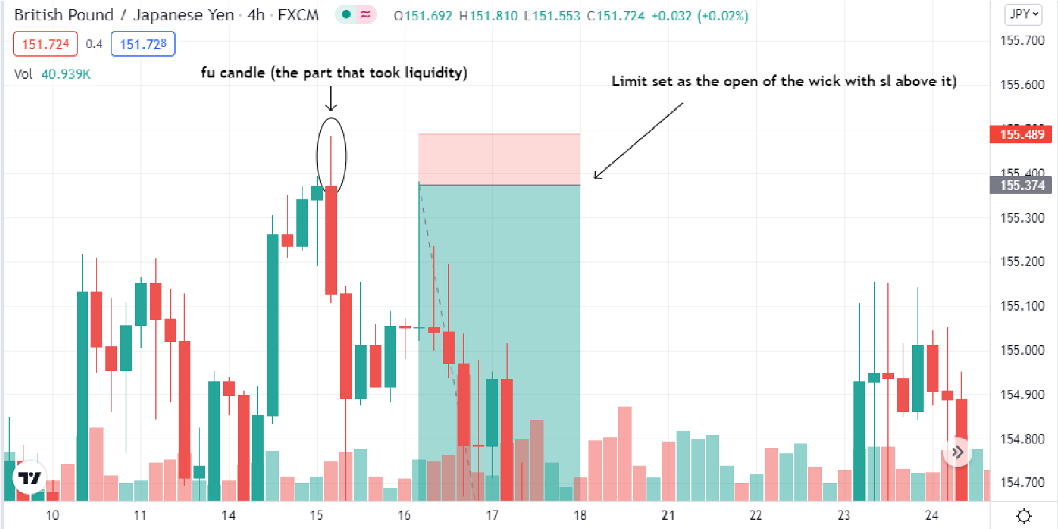
Let me tell you. True FU retests are the strongest trade setups you will ever find. If your position holds especially on a 4hr or daily time frame it has the potential for an amazing swing trade. However not only that this works on all timeframes although I wouldn't recommend going lower than 5m time frame for major forex pairs or 15m timeframe on minor pairs in order to find them.
Only on volatile pairs like gold I recommend using lower than 5m.
This following trade went like this:
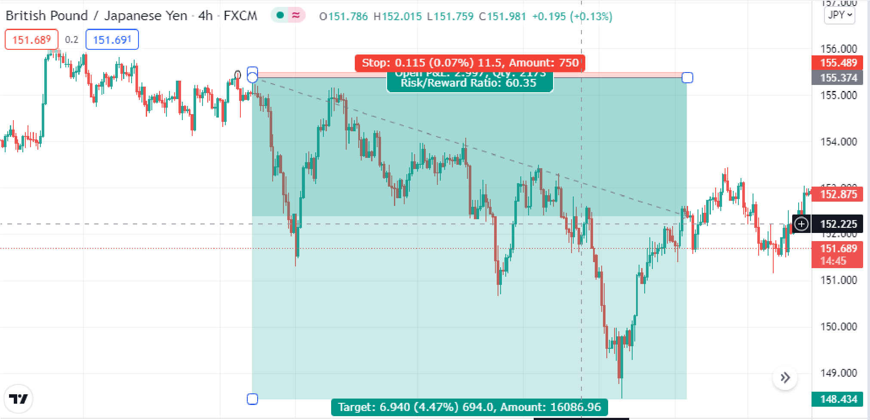
See what I mean? When you trade with the banks (that was the exact point they got in) you find the true moves in the markets such as this. Be patient and trust your instincts with all I have taught you by now and it will all fall into place. If your bias is right (on the same side as the banks) you can find some really amazing trade setups.

Chapter five: Imbalances

Imbalances for market direction
Now we have learnt so much about the true way to trade on the side of the banks yet one principle remains. Imbalances. The truth of imbalances? They leave alot of liquidity behind and as such must be filled in. If price moves 500 pips in one direction let's say with a news release. Even though manipulation will occur first yet still people who are just adding positions with the momentum are making profits which of course the banks cant allow and have a method to take them out. These following principles apply to all timeframes.
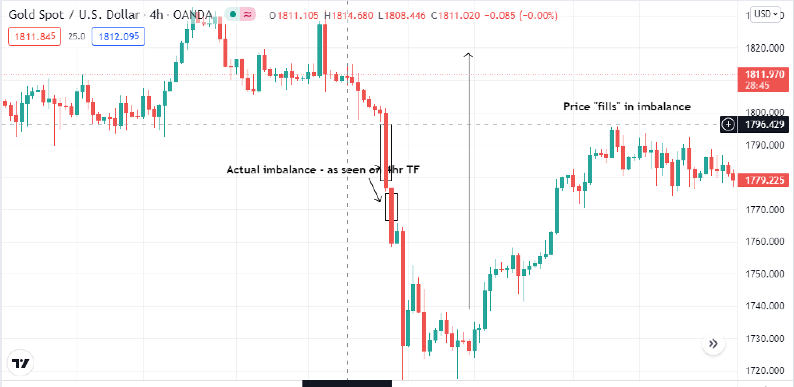
Price dropped heavily and in one swift motion. We know this has caused an imbalance - between sellers and buyers but mainly a lot of liquidity for all those who somehow caught the move down. How to mark these imbalances out as I have did? Simple it's whatever area of price that hasn't been retested yet. So draw it from the wick of the last candle before to the wick of the next candle after it.
Now this concept works just like liquidity; you may add it to your list of confirmations. Just like liquidity being taken can be a sign to take a trade and having liquidity to target be another. Imbalances are the same. Look to see if previous imbalances have been filled and see if you have imbalances to target.

Refined Imalances for sniper entries
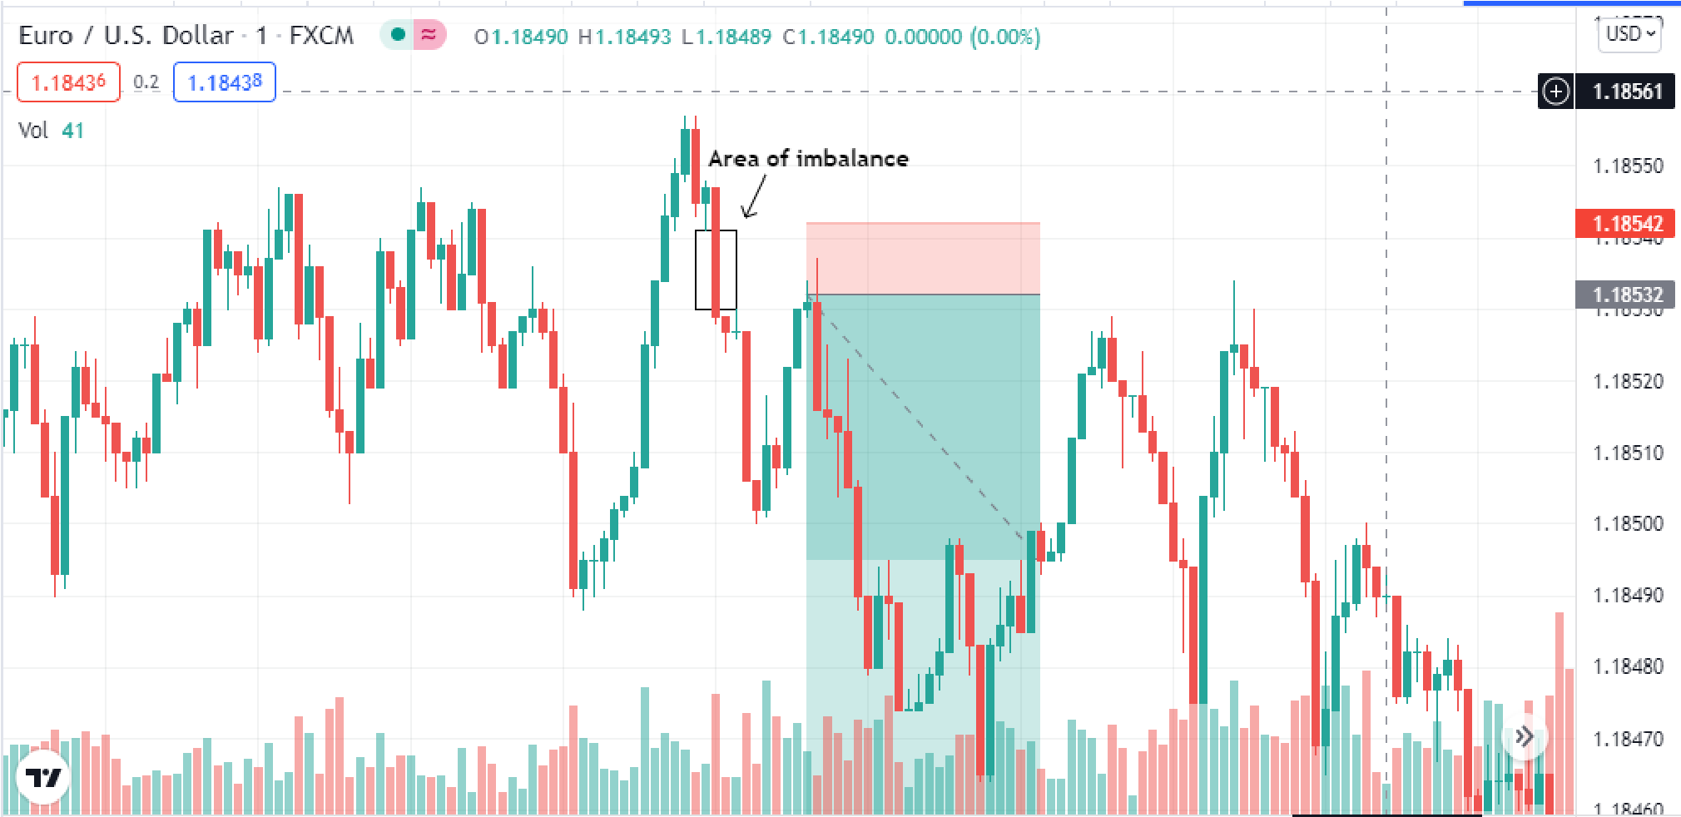
Now let's use the same concept on the 1m timeframe. I can assure you that you will find no one else is teaching you this like how i am the opportunities using it are endless. Remember what we said about risk to reward? It's not about how many pips you catch rather how much you are risking. Using this method we find a very insanely small SL in this example with just one pip. That means if you catch 50 pips it's a 1:50 RR lol. This repeats over and over on all timeframes but i used the 1m to really refine it down and show you how to do it. Another example below. Remember this is only using it for entries not market direction (that you use the whole imbalance not refining it)
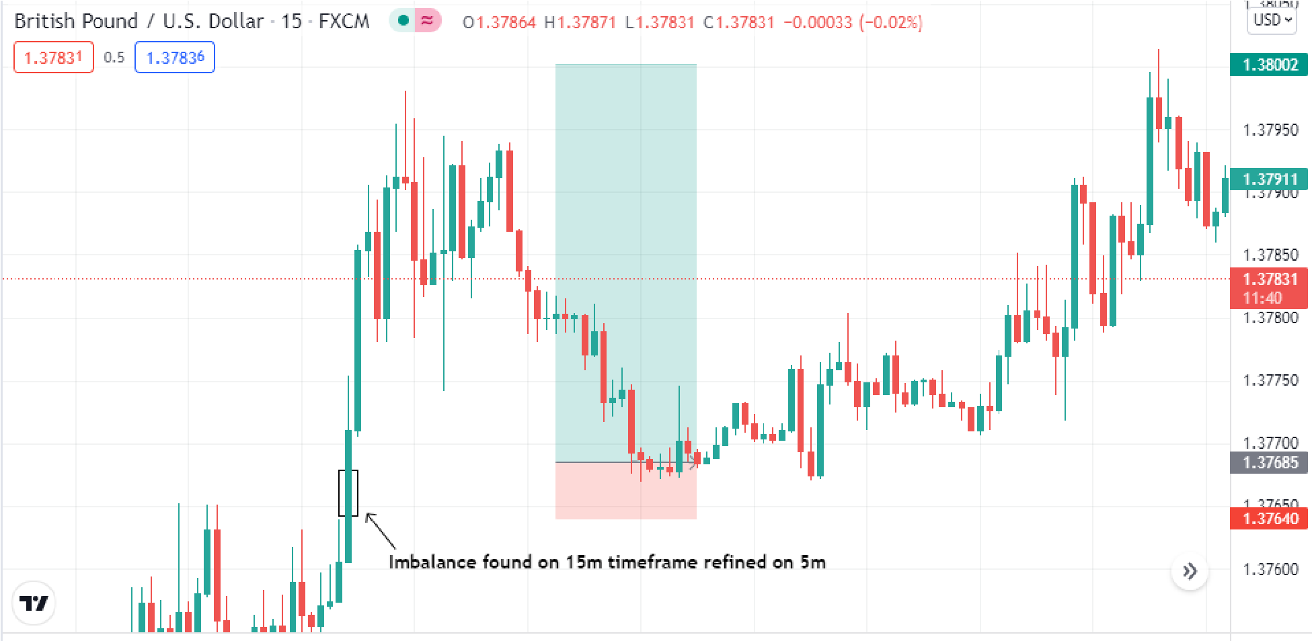

Imbalances as they form and how to utilize them
Now let's talk about imbalanced candles. There is a reason i put this last because its alot more complex and you need to understand what I am saying here fully in order to grasp it.
A balanced candle in the market : An imbalance candle in the market
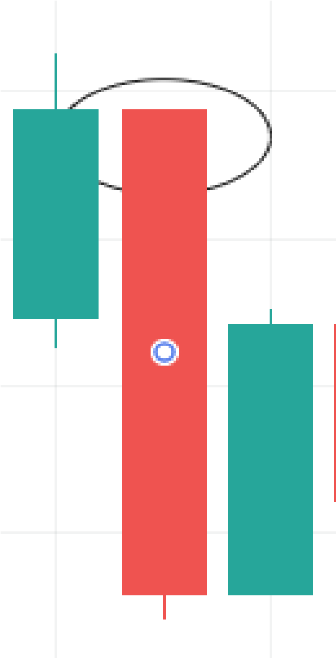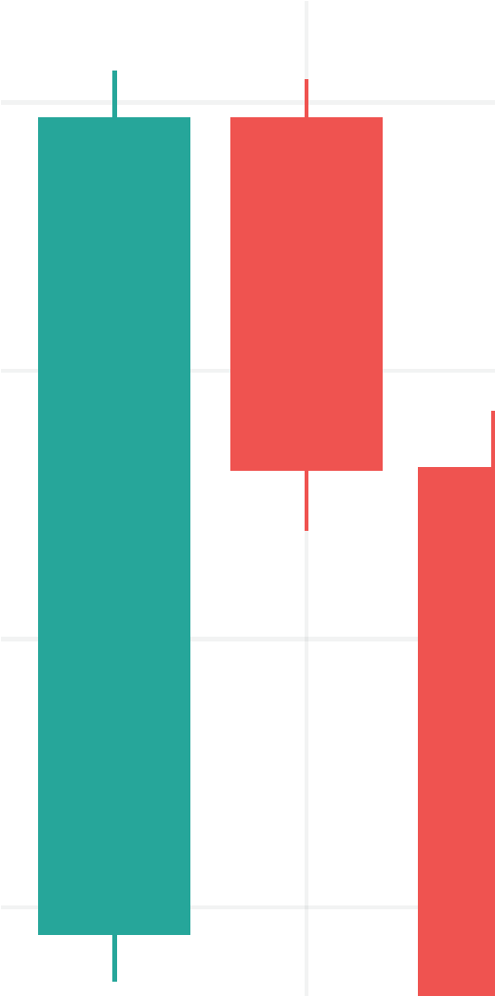
Balanced moves will hold - Imbalanced moves will never hold. No matter the time frame if you see a candle forming like this you should know that it is not in line with the true market direction until it is filled. We only take balanced moves - when you get more deeper into market analysis you will see just how powerful this really is. This concept is best explained with an example:
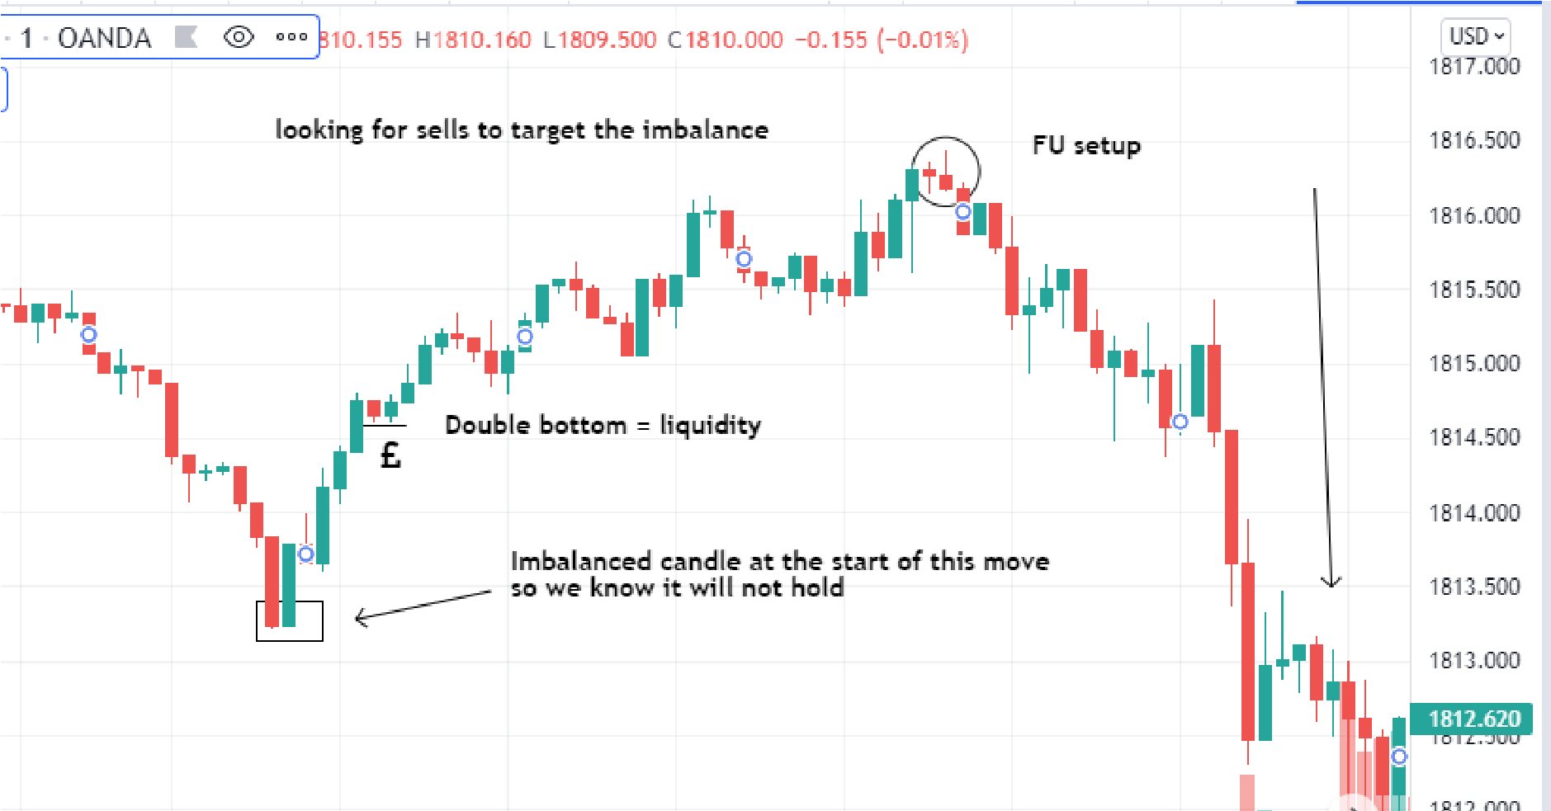
Remember what I said about these 5 principles being all you needed? Well combine these together and you will truly dominate the markets. Because these concepts are not just “patterns” it's a way to actually understand the markets and react to each candle you see. Also we trade with utmost precision so we find the biggest risk to reward trades - with a high win rate because we understand the true moves of the markets.
I thought it would be useful to add a confirmation list here so that you may refer to before placing a trade:
- Price makes sense on the daily timeframe
- Price is in an institutional zone
- Liquidity has been taken
- We have liquidity to target
- An “FU” scenario has formed
- We are awaiting a retest of a FU candle
- Price has done an imbalance fill
- We have an imbalance to target
These are the fundamental rules of trading -of course it goes deeper but these rules apply in EVERY move of the market. Forget all you have learnt about trading and only practise what you have learnt in this book… I promise you it will change your trading life forever.

XAU/USD and conclusion
Think of it like this. Gold moves 10x as fast as forex pairs therefore 10x the amount of manipulation must occur. I'm sure all traders can relate: you either love gold or hate gold (or both) the reason being you can make money so easily yet you can lose it just the same. Well not if you trade with the banks. I urge you as a reader of this ebook to focus on mastering gold - the king of all pairs. If you can master this pair then you will unlock the markets and understand the true move always.
Now I have taught you to analyse the markets correctly, open up xau/usd and study past data. Look how often price manipulates and stops hunts on ALL timeframes. It is truly quite remarkable and testament to just how much the banks trick people. This is the flaw in the plan of the banks… by doing what they do they have now also left behind a trail of data and patterns we can now exploit to really take trading to the next level for the common person.
I'm sure you guys have seen other institutional traders before and the “smart money concept”. However their methodology is outdated and lacks the practical means to find high RR trades on a daily basis. They are also sl hunted. When you see how fast gold moves and how often the manipulation occurs.. You will understand just how manipulated the markets are and you will find these trades not just weekly or monthly but on a DAILY basis.
You are now a “new” trader. All you know about trading is false, think using only these principles I have taught you in this book and I promise you… trading will be like second nature to you. I assume you know me now and want to trade gold (mainly) just like me and I can tell you that you now have the means to do so.
Believe in yourself, act on all your instincts and keep your psychology sharp, never over risking. Trading is a game of emotions first of all before analysis and I leave you with that... Master your mindset and follow the banks and you have successfully conquered the markets.


